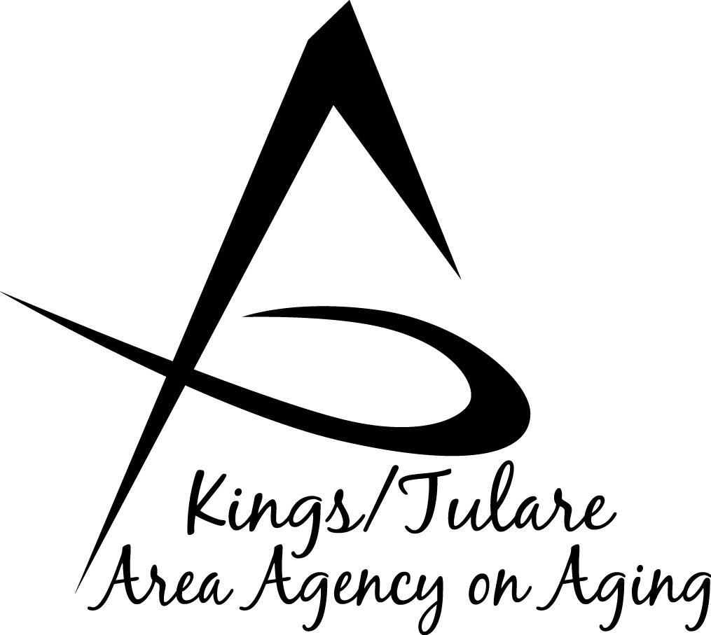
GOVERNING BOARD MINUTES

To be approved on: Minutes of the October 15, 2018 meeting

January 28, 2019 at Corcoran Senior Center ………………………………………………………800 Dairy Avenue, Corcoran, CA 93212

GOVERNING BOARD MEMBERS PRESENT:
Richard Fagundes, Kings Co. – Dist. 5
Pete Vander Poel, Vice Chair Tulare Co. – Dist. 2
Amy Shuklian, Tulare Co. – Dist. 3
Craig Pedersen, Kings Co. – Dist. 4
Kuyler Crocker, Tulare Co. – Dist. 1

GOVERNING BOARD MEMBERS ABSENT:
None

COUNCIL MEMBERS PRESENT:
Marlene Chambers
Betsey Foote
Dan Fox
Grace Henn
Kyle Melton
Bobbie Wartson
Suzann Wray

STAFF PRESENT:
Juliet Webb, K/T AAA Director
Jamie Sharma, Tulare Co. Aging Services Mgr.
Matthew Kredit, Administrative Specialist
Bonnie Quiroz, Adult Family Advocate
Israel Guardado, Staff Services Analyst
Kali Carson, Aging Services Assistant
Christine Tidwell, Administrative Aide

GUESTS PRESENT:
Albert Cendejas, CSET
Cecilia Bobst, Council Member Candidate

- Call to Order – Supervisor Pederson, Chair, called the meeting to order at 10:04 a.m.

- Introductions – Attendance as above.

- Board Member Comments – Tulare County Supervisor Pete Vander Poel said that he likes that the Governing Board is convening in Corcoran. He said in the effort to be more accessible to the community and the seniors, he appreciates that the meetings are held in destinations all over the K/T AAA area.

- Public Comment – Albert Cendejas, CSET, commented that a new program, A Matter of Balance is starting at some of the centers. The program is aimed at fall prevention training. Classes will be conducted in Lindsay, Exeter, Woodlake, Porterville, and Earlimart. Anyone interested can sign up through CSET. Additionally, once the Matter of Balance series of classes are over, the next courses will include Tai Chai (which is good therapy for arthritis). These will also be held at the above senior centers.

- Approval of Minutes of July 30, 2018 – A motion to approve the minutes of the July 30, 2018 meeting was made by Supervisor Vander Poel and seconded by Supervisor Shuklian. The minutes were approved, with Supervisors Fagundes and Pedersen abstaining due to their absence in July.

- Approval of the California Department of Aging (CDA) Contract Amendment and One-Time-Only (OTO) Increased Funding – Administrative Specialist, Matthew Kredit, spoke to this item, saying that every year K/T AAA receives monies that are split among all the providing contractors. Generally, at this time of year, additional funding is received and is brought to the Board as an information item. This year, a Letter of Intent was received from CDA alerting the Agency that it would be receiving significantly more funding. He noted that last year the budget was not approved until April/May and because of that, much of the funding that was supposed to come to the Area Agencies, wasn’t received. CDA, therefore, let the Agencies know ahead of time that they would receive additional funds that would have been received last year if the budget had been approved, timely. In addition to that funding, OTO funds are distributed at this time of year. OTO funds are funds that were received in the previous year but that the Agencies did not have the ability to spend out. He noted that there was more money in the Letter of Intent than normal, but not as much in OTO funding because last year’s budget was so short. All together, the K/T AAA received an additional $441,213, which is above the threshold for the Director to sign off on accepting and which requires approval by the Board. This agenda item (#6) is the request for the Board to accept the additional funding. Item #7 is an explanation of how the funding will be split.

Supervisor Vander Poel said the additional funding is something to be excited about. Mr. Kredit noted that the CDA let the Area Agencies know, in early August what the Letter of Intent funding was going to be so he was able to let each one of the contractors know that the funding was coming and that if they had a need, for instance of a piece of equipment (such as a freezer or a van); they could line it up and start preparing to receive the money in October and requesting approval.

Supervisor Pedersen asked if there were any limitations on how this funding can be spent. Mr. Kredit said that since it is earmarked as last year’s funds it has to be spent first - noting this is mostly behind-the-scenes accounting. When a subcontractor sends K/T AAA an invoice the accountant ensures that funds routed to the Agency in the prior year are spent first. The funding falls into a certain categories and can only be spent within those categories although limited transfers are allowed between certain categories. For example, CSET has a freezer that needs replacing, so some funding can be taken out of Senior Services and moved into Nutrition to pay for the item. Outside of the CDA guidelines, the Agency has to follow from within the funding sources themselves.

On a motion by Supervisor Vander Poel, which was seconded by Supervisor Shuklian, the contract amendment (AP-1819-15, Amendment #1) for increased funding was approved.

(Vander Poel/Shuklian Res. No. 18-010)

- Approval of Provider Contract Amendments (OTO) – (Res. No. 18-011)
- Kings County Commission on Aging (KCCOA) $ 640,103
- City of Tulare $ 114,717
- Community Services & Employment Title III (CSET) $ 1,235,100
- Valley Adult Day Services (VADS, formerly PADS) $ 102,406
- Valley Caregiver Resource Center (VCRC) $ 102,406

Mr. Kredit said that this item is connected to Item #6; the funding received being distributed out to the contractors. He noted that the amount of the contract is the full amount of the contract and not just the additional funding. The additional portion was indicated in the packet of information provided to Supervisors in the Board packets, broken out between the OTO amounts and the additional Letter of Intent funding. K/T AAA follows the Joint Powers Agreement (JPA), when it comes to splits between Kings County and Tulare County. Mr. Kredit said he followed Requests for Proposal (RFPs) in regard to how III-E funding is split. This is split in the same way as the budget was split originally. Supervisor Crocker motioned to approve the agreements with the stated contractors for the increased funding amounts; Supervisor Shuklian seconded the motion, which was approved unanimously. (Crocker/Shuklian Res. No. 011)

- Approval of the California Health Advocates (CHA), Senior Medicare Patrol (SMP) Contract – Israel Guardado, K/T AAA Analyst reported that this item provides $3,500 for the Senior Medicare Patrol. It is part of the HICAP program and the funding is used to support the mission of the SMP program, which is to empower and assist Medicare beneficiaries to prevent, detect, and report healthcare fraud and abuse through counseling and education. This requires a lot of training and outreach with the main purpose of catching fraudulent activity. Supervisor Vander Poel moved for approval to accept the SMP funding; Supervisor Crocker seconded the motion, which was accepted by unanimous vote. (Vander Poel/Crocker Res. No. 18-012)

- CDA Medicare Improvements for Patients and Providers Act (MIPPA) Contract – Mr. Guardado said this contract is also related to the HICAP program - MIPPA is funding in the amount of $58,524. This contract is through September 29, 2020. It is a 2 years and 3 months budget, split out between those time periods. The program provides outreach, education, and enrollment assistance to help eligible beneficiaries with low-income subsidy and Medicare savings programs. Supervisor Fagundes moved to approve the acceptance of the funding; Supervisor Vander Poel seconded the motion, which carried unanimously. (Fagundes/Vander Poel Res. No. 18-013)

- Recommendation to Appoint Cecilia Bobst – Advisory Council member Suzanne Wray spoke on behalf of the Council Membership Committee in recommending candidate Bobst for appointment to the Council. Ms. Bobst manages the Senior Center in Dinuba CA and has been successful in building up the attendance of that center, considerably. Ms. Wray said Ms. Bobst is a great advocate for senior issues and will be a good addition to the Council. Supervisor Vander Poel said with that glowing recommendation he moves for approval of the appointment; Supervisor Shuklian seconded the motion, which was carried unanimously. (Vander Poel/ Shuklian Res. No. 18-014)

- Staff Reports
- Bonnie Quiroz, Tulare County Senior Advocate, said that in the Board packets there was a copy of the CA Dept. of Food & Agriculture (CDFA) report on the 2018 season Farmers Market. She said every second year the CDFA conducts a monitoring of the Senior Farmers Market coupon program, which this year was a desk report. She noted the CDFA liked the fact that K/T AAA made attempts to expand the reach of the program by taking coupons out to the centers (via proxy), including Goshen, Earlimart, and Woodlake, as well as to the community of Three Rivers. All these attempts resulted in good responses. Additionally, Agency staff, along with CSET staff, were able to get some of the Home Bound senior clients signed up for the coupons, again via proxy. Initially, 1,000 booklets were released to K/T AAA, with an additional 200 later in the season.
- Kali Carson reported that K/T AAA (Tulare Co.) has just begun its Stockings for Seniors campaign that is done every year. Donation boxes are going out to the various collection locations. A fund-raising pancake breakfast is scheduled for Saturday, October 20, 2018, with tickets at $10 each. Half of the proceeds will go to the campaign.
- Ms. Bobbie Wartson reported that Kings County had its senior picnic in September with over 400 people signing in. The event had 93 student volunteers to help with the event. Transportation is usually a problem, but Ms. Wartson said this year she reached out to Kings Rehabilitation and they provided two buses. Also Adventist Health donated $5,000 to help sponsor the event. Elvis (Jeremy Pearce) was in attendance to entertain the crowd.

On a different note, Ms. Wartson said that KCCOA just finished a fund raiser to bring awareness of and for the prevention of domestic violence. Approximately 300 attendees participated. Additionally, KCCOA helped with the food bank in September, serving 556 people, 483 of which were seniors.

Kings County also distributed its full portion of the Farmers Market vouchers, including distribution at the Corcoran Senior Center (via proxy participation).

KCCOA distributes candy through the Armona School District for the Halloween holiday as a community connection. To help, purchased bags of candy can be donated to the Kings County Commission on Aging.

- Advisory Council Report
- Council Vice Chair, Marlene Chambers, reported that the Council is developing an Annual Report that it hopes to have completed by the end of the year in order to present to the Governing Board.
- Ms. Chambers also reported that Council member Benjamin Cordova has tendered his resignation.

Supervisor Vander Poel said that at a “ribbon cutting” earlier in the day, Mr. Dick Johnson inquired about serving as a member of the K/T AAA Advisory Council. Mr. Johnson was previously a member of the Council and would like to be reappointed.

Juliet Webb, K/T AAA Director noted that she wanted to discuss the 2019 Governing Board meeting schedule. She said that depending on which supervisors are appointed to serve on the Board, it could impact the scheduling and that if the schedule doesn’t change, there may end up being a time conflict between the County meetings and the K/T AAA Board meetings, as there has been during 2018. She said a decision doesn’t need to be made immediately, but the concern should be reviewed. The meeting time slot can be changed to make sure there is a quorum for the Board meetings.

- Adjourn – The meeting was adjourned at 10:25 a.m.

Respectfully submitted,

Juliet Webb

K/T AAA Director

