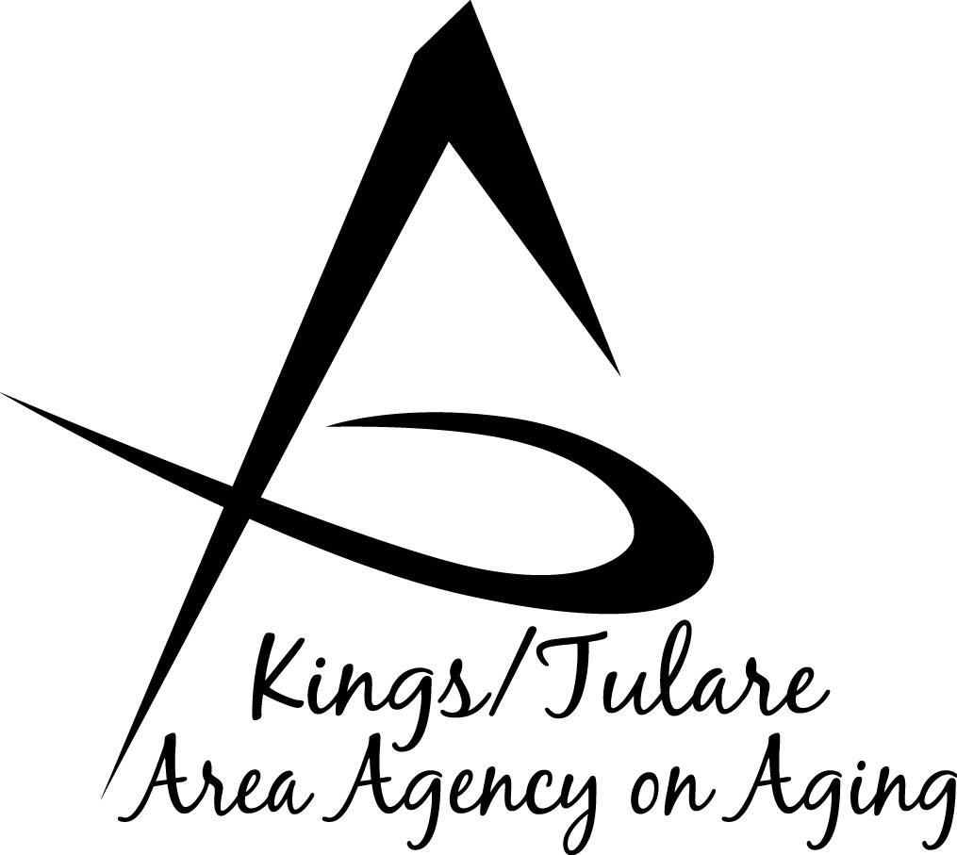
GOVERNING BOARD MINUTES

To be approved on: Minutes of the May 14, 2018 meeting

July 30, 2018 at Cutler-Orosi Senior Center ………………………………………………………12691 Ave 408, Cutler, CA A 93615

GOVERNING BOARD MEMBERS PRESENT:
Richard Fagundes, Kings Co. – Dist. 5
Pete Vander Poel, Vice Chair Tulare Co. – Dist. 2
Amy Shuklian, Tulare Co. – Dist. 3
Craig Pedersen, Kings Co. – Dist. 4

GOVERNING BOARD MEMBERS ABSENT:
Kuyler Crocker, Tulare Co. – Dist. 1

COUNCIL MEMBERS PRESENT:
Marlene Chambers
Dan Fox
Bobbie Wartson
Dr. David Wood, Advisory Council Chair
Suzann Wray

STAFF PRESENT:
Juliet Webb, K/T AAA Director
Jamie Sharma, Tulare Co. Aging Services Mgr.
Matthew Kredit, Administrative Specialist
Bonnie Quiroz, Adult Family Advocate
Israel Guardado, Staff Services Analyst
Christine Tidwell, Administrative Aide
Kali Carson, Office Assistant, Aging Srvcs.

GUESTS PRESENT:
Albert Cendejas, CSET
Raquel Gomez, CSET
Julie Gurrola, Site Manager
Plus numerous Cutler-Orosi seniors

- Call to Order – Supervisor Pederson, Chair, called the meeting to order at 10:01 a.m.

- Introductions – Attendance as above.

- Board Member Comments – Supervisor Vander Poel commented that he appreciates rotating the meetings throughout the different communities and locations of the K/T AAA.

- Public Comment – Albert Cendejas, CSET, welcomed everyone and thanked the Board and Council members and K/T AAA staff for coming to the Cutler-Orosi center to conduct their meetings.

- Approval of Minutes of March 19, 2018 – Supervisor Vander Poel said that if there were no comments or corrections he moved to approve the minutes of the March 19, 2018, Board meeting; Supervisor Shuklian seconded the motion. The minutes were approved unanimously by those Supervisors in attendance. Supervisor Crocker was not present.

- Senior Day in the Park – Albert Cendejas said this year’s Senior Day in the Park event is here! Everything needs to be finalized by Friday, May 18, 2018. He noted that transportation is always an obstacle to get seniors to the event, so he acknowledged the transportation team that helped line up ways of transporting seniors to the event. He commented that from the Cutler-Orosi area there has always been support from the schools by using their school buses during off hours. Supervisor Pedersen apologized for his not being able to attend due to his being in Sacramento.

- Request for Proposal (RFP No. K/T AAA 18-01) – Israel Guardado reported that on March 5, 2018, the K/T AAA released an RFP for senior services in Kings County. It included all the services currently being provided in Kings County by the Kings County Commission on Aging (KCCOA) through a sub-contract with Kings County. The deadline for prospective bidders to submit proposals was April 16, 2018. On the deadline day, K/T AAA received only one proposal, submitted by KCCOA. The proposal was reviewed and evaluated by an evaluation committee made up of four individuals selected by the K/T AAA. The committee consisted of staff, an Advisory Council member, and peers from other local agencies. The proposal was evaluated on the following criteria: administrative capabilities, multi-service capability, program description, relevant experience, service categories provided, and efficient use of funds. Based on the criteria established in the RFP of a possible 600 points, the proposal scored 513 points, or 85.5 percent of the available points.

The final authority to award the contract rests solely with the K/T AAA Governing Board. Based on the submitted proposal and score, staff recommends the contract be awarded to the sole bidder, Kings County Commission on Aging (KCCOA).

Supervisor Vander Poel commented that he knew we expected this applicant for the RFP, but was there not expectation that there were going to be other proposals from other organizations? Juliet Webb, K/T AAA Director, said the K/T AAA received five Letters of Intent to bid, but only one organization actually submitted. Supervisor Shuklian motioned to approve; Supervisor Vander Poel seconded the motion. The motion carried unanimously. (Shuklian/Vander Poel Res. No. 18-005)

- Approval of K/T AAA Area Plan Update (APU) FY 18/19 – Mr. Guardado said the Area Plan is a four-year plan that outlines the K/T AAA area services and goals. The current plan outlines fiscal years 2016 through 2020, and is updated on a yearly basis. The Update is due to the State on May 1; so on May 1st a draft is submitted to the State pending approval by the Governing Board. Mr. Guardado said that while the funding has slightly increased, the K/T AAA will continue to provide the same services as in previous years. Some of the pending changes that have not been included in the APU are the HICAP performance measures. These measures are set by the State and have not yet been released by the State. Once they are received, the measures will be included in the APU. Another change is the LGBT Disparities Reduction Act of 2016 Data Collections Systems Update. This is in progress and it is expected that an updated system will be ready and in place by July 1, 2018. He said a “walk through” of the system is scheduled for late in the week before it goes live to the providers. The full Area Plan is available if requested, but he noted that a summary of changes made for FY18/19 was included in the meeting agenda packet. Upon the Governing Board’s approval and the authorized signature on the Transmittal Letter, K/T AAA will submit the final APU to the State. Although overall, the Plan has stayed relatively the same with very few changes that he would classify as major, Mr. Guardado said he wanted to point out some of the population changes. The Plan includes projected population changes from the California Department of Finance. He highlighted the minority aged 60+ population compared to the non-minority 60+ population - while both groups are increasing, the minority group is increasing at a faster pace. This projected change is anticipated to continue for the next 30 years. Other changes he pointed out were the service unit objectives – those that are experiencing changes of more than 10 percent. He said two major factors contribute to this. For instance, the Community Education is expected to increase 291 percent. Factors that play into the change include the way in which the goals are calculated. There are now different baseline numbers to establish those goals, and the other variable factor is the timing of when the goals are set. Because of the due dates, the contracted providers have to set the goals before the funding is released. So, K/T AAA is asking the contractors to anticipate how many services they are expecting to give when they don’t know what their funding will actually be. This leads to goals that are more conservative in nature. The 291 percent is entirely due to the ways the goals are set and the baseline used to set the goals.

Supervisor Pedersen asked if there had been a discussion about changing the process and the timing of the submission of the document. Matthew Kredit, Administrative Specialist, said there had been a conversation approximately one year ago regarding changing some of the timing on when several of the planning documents are due. Timing is in part stipulated in the K/T AAA Joint Powers Agreement (JPA); for instance, when the budget is due. He said the reason this is done, is so that Tulare County and Kings County can get an idea and estimate of what the County match for each County will be. Mr. Kredit said it hasn’t changed percentage-wise in the last several years, although now with the King’s County RFP, Kings County will be picking up a larger share.

Ms. Webb mentioned the State’s timeline for submitting said documents – which creates a situation where the Agency has to have the projections and goals in before it knows the information to back it up. Mr. Guardado said the actual funding is released sometime in April. May 1 is the date due to the State for the Area Plan and its annual updates, with tentative goals. Supervisor Pedersen said if it was a standard problem for everyone, why wouldn’t the State adjust the dates accordingly to allow for actual numbers? (No direct answer was given).

Mr. Guardado said the APU needs the Board’s approval and a signature on the Transmittal Letter. Supervisor Vander Poel moved for approval, with Supervisor Suklian seconding the motion. Supervisor Pedersen said before the Board votes, he wanted to clarify if the APU will be amended at some point with further information that is generated? Mr. Guardado responded that usually the document is amended, but not until the next yearly cycle, when the goals for the new year will be given. The Agency has never gone back and changed the goals that were set, initially. So far, that has been the business practice. Following a motion and a second, the vote carried the motion for approval. (Vander Poel/Shuklian Res. No. 18-006)

- Approval of the FY1819 California Department of Aging (CDA) Grant Award Contracts – Matthew Kredit said this funding was brought before the Board in March, as estimates. He noted that the Agency did receive much of the funding that it received last year, although it had been hinted that there might be cuts, especially to the Older American (Area Plan) Grant, but there were no cuts to that grant. Also, the Agency received the same dollar amount in the MSSP grant for FY18/19 as was received in FY17/18. Regarding the Title V grant, K/T AAA elected to continue receiving this funding from the CDA. He noted the Title V program did receive a funding cut.

Mr. Kredit said that, last year, when the contracts were presented to the Board for approval, the Health Insurance Counseling and Advocacy Program (HICAP) was a three-year contract, so the approval last year covers the current contract time period. The contracts up for approval are the Area Plan (AP-1819-15) in the amount of 1,983,324; Title V Senior Employment Training (TV-1819-15) in the amount of $91,378; and the Multipurpose Senior Services Program (MS-1819-33) in the amount of $698,455. Supervisor Fagundes moved for approval; Supervisor Shuklian seconded the motion, and a vote to approve followed. (Fagundes/Shuklian Res. No. 18-007)

- Contract Authorities for FY1819 – Mr. Kredit said this item is informational only, as all the provider contracts will be brought to the Board at its July meeting. He noted the estimated funding amounts were brought to the Board at its March meeting. The amounts indicated in this item are what will be put forward in the actual contracts. He said that he had brought budget updates, if any Board member wished to see them. The contracts will be brought for the Board’s approval and the Chair’s signature in July.

Advisory Council Chair, Dr. David Wood asked about the Homebound Senior Social Network contract with Mental Health funding, at $25,000. He inquired if this is part of the Prevention and Early Intervention (PEI) program, which Mr. Kredit said that it is; and noted that it is a Letter to File between Human Services and Mental Health departments.

Ms. Webb pointed out that, historically, the K/T AAA Governing Board has canceled its July Board meeting due to there not being any action items; however, this year, staff will be bringing back the provider contracts in July for approval and signature. She said there have been multiple requests from the Board to be more transparent, with a desire to actually see the provider contracts. Prior to this year, staff has not brought those full contracts to the Board for its review. Past practice was to receive authority to enter into the contract with the providers, but the contracts themselves were not provided for review to the Board members. In July, the contracts will have been returned to the K/T AAA, with the scope of work and what is being covered by each contract. In providing these to the Board, it is thought this will be better for informational purposes and transparency.

- Staff Reports
- Bonnie Quiroz, the Tulare County Elder and Dependent Adult Family Advocate with Aging Services announced that on June 19, 2018, in front of Government Plaza there will be a World Elder Abuse Awareness and Prevention event, starting at 9 a.m. The organizing committee has asked if any Board members would be available to participate. Supervisor Shuklian said she will be there. Ms. Quiroz said further information will be provided. The Sheriff’s office, the District Attorney’s office and other community partners will be participating.

Advisory Council member and KCCOA Director, Ms. Bobbie Wartson, announced that Kings County will also be holding an event at the Civic Auditorium to recognize Elder Abuse Prevention month. The date is still to be confirmed. KCCOA is working with the Victim Witnesses Program.

- Ms. Quiroz announced the Farmers Market coupon distribution for 2018 is set to begin in Tulare County on June 7th in Visalia. She distributed the schedule for the Tulare markets. She noted that there had been discussion on how to get more availability to more seniors, especially in rural communities. To facilitate this, she will be arranging for some of the farmers to be at the sites. Also, arrangements will be made to help seniors on the Home Bound Meal program to be able to participate in the program via proxy. It was noted that this model is being looked at for use in other counties in an effort to get coupon distribution and availability to more seniors that may not otherwise have opportunity to participate.

Kings County will begin its distribution on Thursday, June 14, 2018, at the Hanford Farmers Market. Flyers were distributed with dates, times, and location. According to the conventional funding split, Kings County receives 23 percent of the coupons.

- Ms. Quiroz said that Veterans Opportunity Day was very successful with 110 guests, who were able to learn about services and resources as well as about possible job opportunities and employment. Ms. Webb commented that she is impressed by how many exhibitors attend to provide information for the veteran population.

- Advisory Council Report
- Dr. David Wood, Council Chair, said the Council is taking advantage of Dan Fox’s expertise in transportation matters in connecting up with Aging in Community (AIC). AIC is the Three Rivers non-profit organization in the community of Three Rivers that helps coordinate services for the seniors of Three Rivers, including transportation, which is a major issue in rural communities.

- Dr. Wood commented that the K/T AAA has been participating more regularly in Triple-A Council of California (TACC), most recently sending Ms. Bobbie Wartson as its representative to the quarterly meeting. Christine Tidwell provides a written quarterly update on K/T AAA activities. This provides more visibility at the State level for the K/T AAA. TACC is a state-wide meeting for the Advisory Councils for the Area Agencies on Aging. Ms. Wartson said she enjoyed the experience, noting that one of the days was Senior Rally Day at the State Capitol. She said that some AAAs have Secret Shoppers at their senior sites. These are “under cover” people who attend the sites to see how the services are provided and can give a report. She commented that she would like to have a Secret Shopper visit the Avenal and Corcoran sites and may try to implement the idea.

- Regarding the California Senior Legislature (CSL), Dr. Wood said that Ms. Wartson has applied to be the K/T AAA PSA 15 Senior Assemblywoman. Dr. Wood has been serving as the CSL Senator since taking over the vacancy left by Don Turner, and he will continue to serve in that capacity. At the Advisory Council meeting later in the day, those positions will be declared by acclamation, as there are no other competing candidates. CSL representatives help pilot legislation considered to be relevant to seniors. High priority items then get lobbied at the State or Federal level for formal legislation.

- Regarding the Tulare County Proclamation declaring May as Older Americans Month, Dr. Wood reported that the Advisory Council had several of its longest-serving members present at the Board of Supervisors meeting the day it was issued. Council members in attendance were: Suzann Wray, Kyle Melton, Marlene Chambers, and Sharon Lamagno.

Jamie Sharma, the Aging Services Manager said that the K/T AAA would like to present the proclamation to the Cutler-Orosi Senior Center. Ms. Sharma asked Julie Gurrola, Site Manager at the Cutler-Orosi center to please join her as she presented the Proclamation to the site in recognition of the seniors for their contributions to the community.

On another issue, one of the seniors at the center brought up the problem of traffic control at particular intersections in Cutler-Orosi. She said that although there is often a police presence, the traffic flow is unusually fast and unruly. Supervisor Vander Poel gave her his contact information in order for her to be able to follow up. Suzann Wray who is a local resident and is familiar with the problem, said that the road in question is a State Highway, and it isn’t a County road. Supervisor Vander Poel said that Supervisors do deal with representatives from the Highway Patrol and can work with them on issues. He also said that Tulare County Association of Government (TCAG) exists to help with these issues and has great communication with the State.

- Adjourn – The meeting was adjourned at 10:49 a.m.

Respectfully submitted,

Juliet Webb

K/T AAA Director

