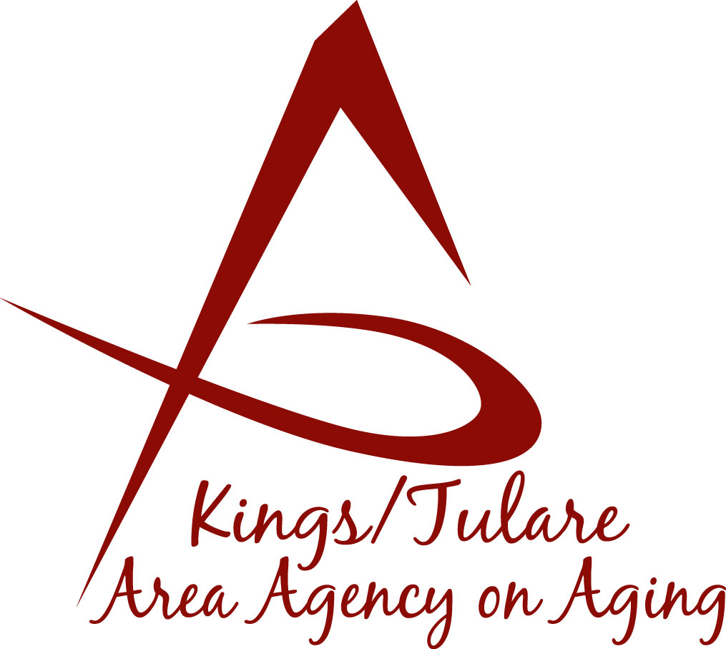ADVISORY COUNCIL AGENDA
Monday, September 16, 2019
10:30 a.m.
CSET Main Office
312 N.W. 3rd Avenue
Visalia, CA 93291

- Call to Order Action

- Introductions of Guests and Council Members Information

3. Public Comment 3 minutes
Any person may directly address the Council at this time on any item on the Agenda or any other items of interest to the public that are within the subject matter jurisdiction of the K/TAAA.

4. Approval of Minutes Action
Members present at the previous meeting may comment or correct minutes
from the meeting held on August 19, 2019.

5. Announcements and Correspondence Information

6. Milestone Updates Information
Information regarding current and former members of the Council

7. Update on CA Senior Legislature (Dr. David Wood) Information

8. Review of CSET Contracted Senior Services (Albert Cendejas) Information

9. Committee Assignments Information

10. Annual Report Information
For presentation to the Governing Board at its October 2019 meeting

11. Staff Reports Information

12. Pending Events Information

13. Development of the October 2019 Council Agenda Information

14. Additional Member Comments Information

15. Adjourn Action
If there is no further business to attend to, members may adjourn the meeting at this time.
Notice to the Public
In compliance with the Americans with Disabilities Act, if you need special assistance to participate in this meeting, please contact Christine Tidwell at (559) 624-8063.
The disclosable public records related to this agenda are available for public inspection at the reception area of the Tulare County Human Services Government Plaza building, 5957 S. Mooney Blvd. Visalia, CA 93277

