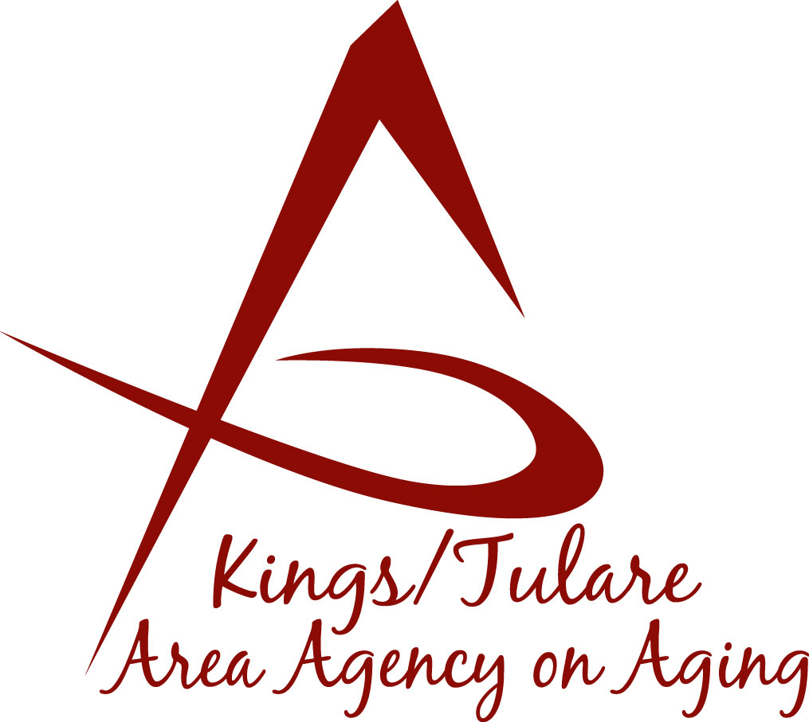
ADVISORY COUNCIL AGENDA
Monday, October 18, 2021
10:45 a.m.
This is meeting will be convened as
an in-person meeting, but will also
have Zoom accessibility

- Call to Order Action

- Introductions of Guests and Council Members Information

- Public Comment 3 minutes
Any person may directly address the Council at this time on any item on the agenda or any other items of interest to the public that are within the subject matter jurisdiction of the K/TAAA.

- Approval of Minutes Action
Members present at the previous meeting may comment or correct minutes from the meeting held on July 19, 2021.

- Announcements and Correspondence Information
6. Milestone Updates Information
Information regarding current and former members of the Council

- California Senior Legislature (Jamie Sharma) Information
Notification of CSL Resignation

8. ABC Committee (Dan Fox) Information
Report out from ABC meeting held on October 4, 2021

9. Roundtable Discussion (Jamie Sharma) Information
Council discussion on what has “worked” during the recent pandemic experience and areas that need to be strengthened

10. Staff Reports Information

11. Development of the January 24, 2022, Council Agenda Information

12. Additional Member Comments Information

12. Adjourn Action
If there is no further business to attend to, members may adjourn the meeting at this time.
Notice to the Public
In compliance with the Americans with Disabilities Act, if you need special assistance to participate in this meeting, please contact Christine Tidwell at (559) 624-8063.
The disclosable public records related to this agenda are available for public inspection at the reception area of the Tulare County Human Services Government Plaza building, 5957 S. Mooney Blvd. Visalia, CA 93277 *For Zoom tele-conference link information call: 559-624-8063.

