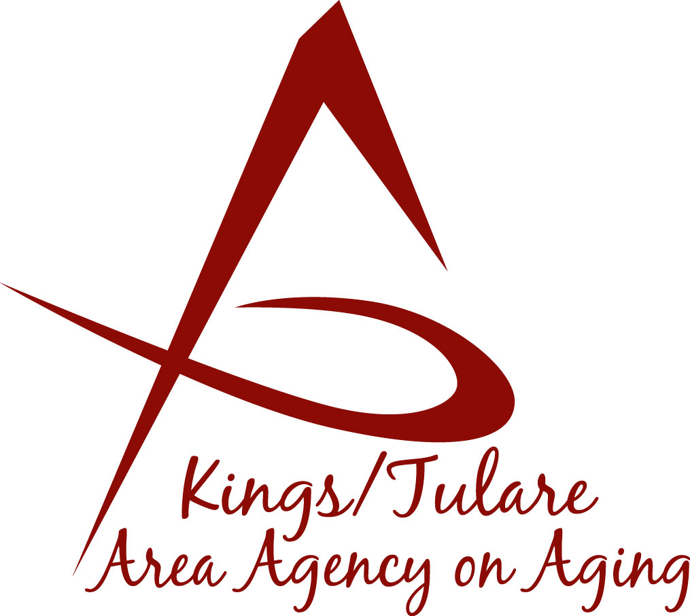
ADVISORY COUNCIL AGENDA
Monday, November 18, 2019
10:30 a.m.
Government Plaza, 5957 S. Mooney Blvd.
Pine North & South Conference Rooms
Visalia, CA 93277

- Call to Order Action

- Introductions of Guests and Council Members Information

3. Public Comment 3 minutes
Any person may directly address the Council at this time on any item on the Agenda or any other items of interest to the public that are within the subject matter jurisdiction of the K/TAAA.

4. Approval of Minutes Action
Members present at the previous meeting may comment or correct minutes
from the meeting held on September 16, 2019. (No quorum at the October mtg.)

5. Announcements and Correspondence Information

6. Milestone Updates Information
Information regarding current and former members of the Council

7. Presentation by In-Home Supportive Services (IHSS), Information
Public Guardian (PG), and Adult Protective Services (APS) Programs

8. Candidate Nominations for Council Chair and Information
Vice Chair (Suzann Wray)
Announcement of prospective officer candidates (for December election)

9. Annual Report Action
Council review and approval for submission to Governing Board

10. Staff Reports Information

11. Pending Events Information

12. Development of the December 2019 Council Agenda Information

13. Additional Member Comments Information

14. Adjourn Action
If there is no further business to attend to, members may adjourn the meeting at this time.
Notice to the Public
In compliance with the Americans with Disabilities Act, if you need special assistance to participate in this meeting, please contact Christine Tidwell at (559) 624-8063.
The disclosable public records related to this agenda are available for public inspection at the reception area of the Tulare County Human Services Government Plaza building, 5957 S. Mooney Blvd. Visalia, CA 93277

