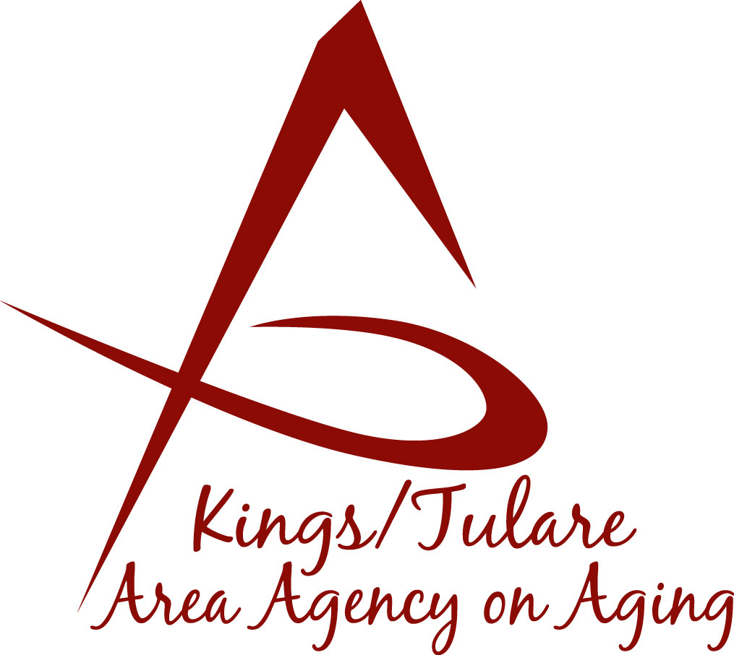ADVISORY COUNCIL AGENDA
Monday, March 19, 2018
10:30 a.m.
Kings County Government Center
Multi-purpose Conference Room
1400 W. Lacey Blvd.
Hanford, CA 93230

- Call to Order Action

- Introductions of Guests and Council Members Information

3. Public Comment 3 minutes
Any person may directly address the Council at this time on any item on the Agenda or any other items of interest to the public that are within the subject matter jurisdiction of the K/TAAA.

4. Approval of Minutes Action
Members present at the previous meeting may comment or correct minutes from the meeting held on February 12, 2018.

5. Announcements and Correspondence Information

6. Milestone Updates Information
Information regarding current and former members of the Council

7. Fair Political Practices Commission (FPPC) Information
Form 700, Statement of Economic Interest

8. Presentation on the Veterans Services Information
Presenter: Ken Cruickshank, Tulare Co. Veterans Service Officer

9. California Senior Legislature (CSL) Elections Information

10. Committee Development Information

11. Retreat Discussion Information

12. Staff Reports Information

13. Development of the April 2018 Council Agenda Information

14. Additional Member Comments Information

15. Adjourn Action
If there is no further business to attend to, members may adjourn the meeting at this time.
Notice to the Public
In compliance with the Americans with Disabilities Act, if you need special assistance to participate in this meeting, please contact Christine Tidwell at (559) 624-8063.
The disclosable public records related to this agenda are available for public inspection at the reception area of the Tulare County Human Services Government Plaza building, 5957 S. Mooney Blvd. Visalia, CA 93277

