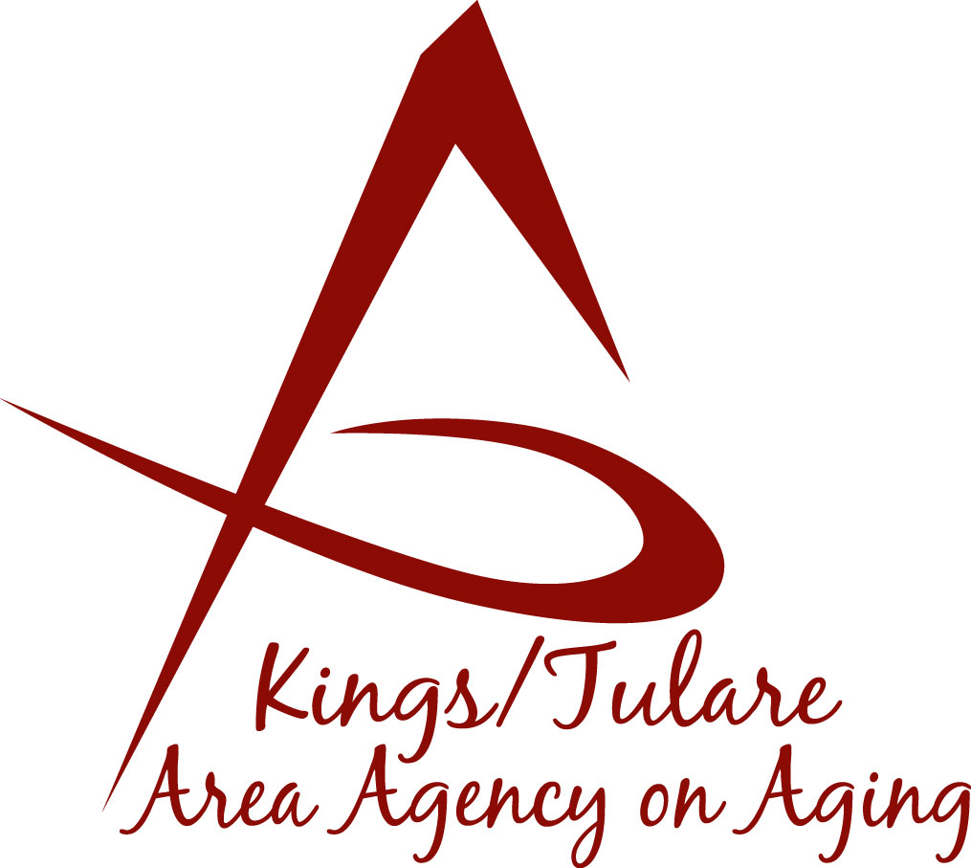ADVISORY COUNCIL AGENDA
Monday, July 22, 2019
1:30 p.m.
Government Plaza Bldg.
5957 S. Mooney Blvd.
RMA Conference Room, 1st Floor
Visalia, CA 93277

- Call to Order Action

- Introductions of Guests and Council Members Information

3. Public Comment 3 minutes
Any person may directly address the Council at this time on any item on the Agenda or any other items of interest to the public that are within the subject matter jurisdiction of the K/TAAA.

4. Approval of Minutes Action
Members present at the previous meeting may comment or correct minutes
from the meeting held on June 24, 2019.

5. Announcements and Correspondence Information

6. Milestone Updates Information
Information regarding current and former members of the Council

7. Candidates for Membership (Suzann Wray, Bobbie Wartson) Action
Advisory Council appointment recommendations:
Mary Thomas, Tulare County
Marianne Osborne, Kings County

8. Annual Report Information
Further work on the Annual Report or suggested modifications/edits

9. Staff Reports Information

10. Pending Events Information

11. Development of the August 2019 Council Agenda Information

12. Additional Member Comments Information

13. Adjourn Action
If there is no further business to attend to, members may adjourn the meeting at this time.
Notice to the Public
In compliance with the Americans with Disabilities Act, if you need special assistance to participate in this meeting, please contact Christine Tidwell at (559) 624-8063.
The disclosable public records related to this agenda are available for public inspection at the reception area of the Tulare County Human Services Government Plaza building, 5957 S. Mooney Blvd. Visalia, CA 93277

