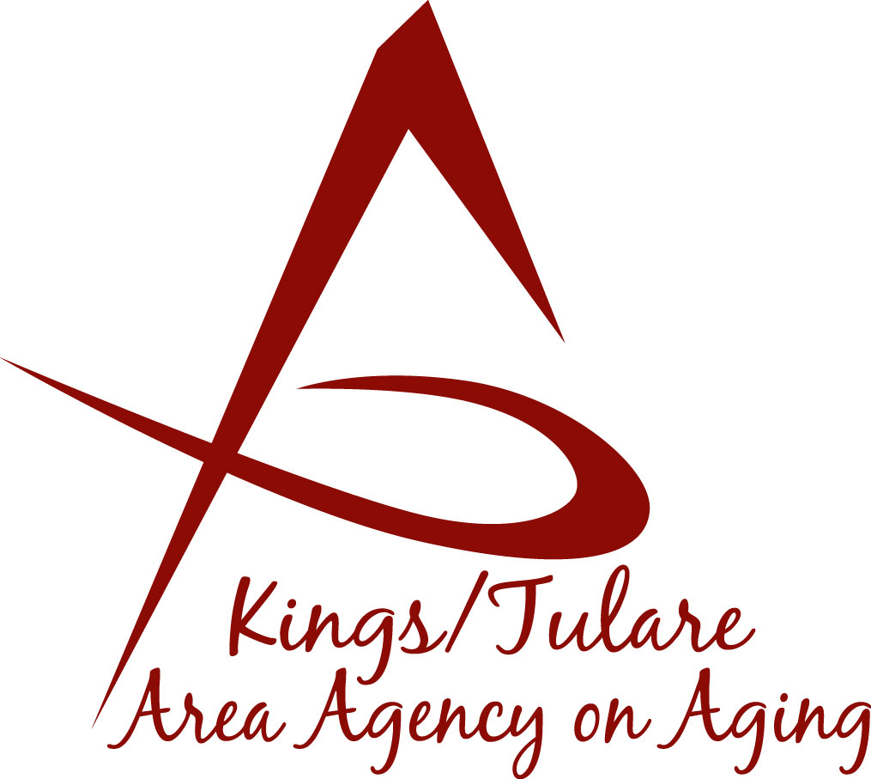
ADVISORY COUNCIL AGENDA
Monday, July 19, 2021
11:00 a.m.
Tele-conference via Zoom

- Call to Order Action

- Introductions of Guests and Council Members Information

- Public Comment 3 minutes
Any person may directly address the Council at this time on any item on the Agenda or any other items of interest to the public that are within the subject matter jurisdiction of the K/TAAA.

- Approval of Minutes Action
Members present at the previous meeting may comment or correct minutes from the meeting held on May 17, 2021.

- Announcements and Correspondence Information
6. Milestone Updates Information
Information regarding current and former members of the Council

7. ABC Committee Re-launch (Dan Fox) Information

8. Staff Reports Information

9. Development of the October 2021 Council Agenda Information

10. Additional Member Comments Information

11. Adjourn Action
If there is no further business to attend to, members may adjourn the meeting at this time.
Notice to the Public
In compliance with the Americans with Disabilities Act, if you need special assistance to participate in this meeting, please contact Christine Tidwell at (559) 624-8063.
The disclosable public records related to this agenda are available for public inspection at the reception area of the Tulare County Human Services Government Plaza building, 5957 S. Mooney Blvd. Visalia, CA 93277 *For Zoom tele-conference link information call: 559-624-8063.

