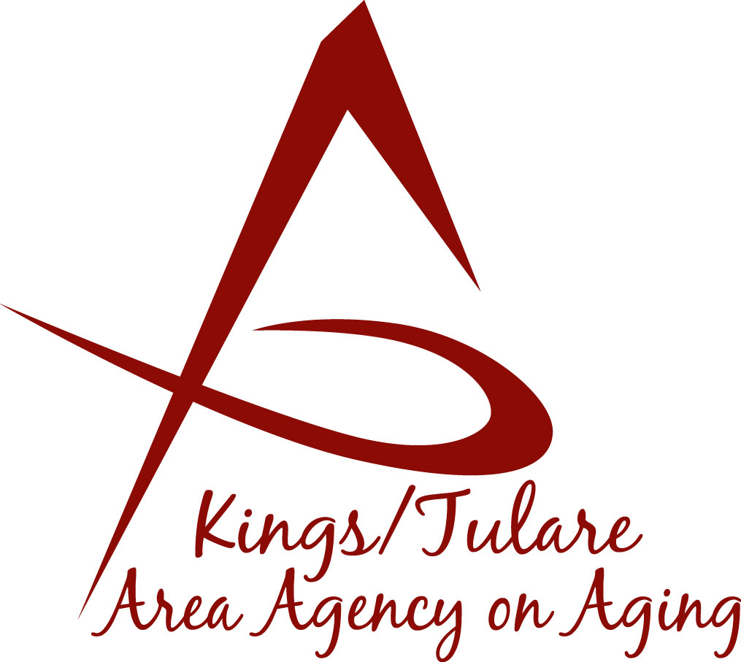ADVISORY COUNCIL AGENDA
Monday, January 22, 2018
10:30 a.m.
Tulare Co. Board of Supervisors Bldg.
Conference Rooms A/B
Visalia, CA 93291

- Call to Order Action

- Introductions of Guests and Council Members Information

3. Public Comment 3 minutes
Any person may directly address the Council at this time on any item on the Agenda or any other items of interest to the public that are within the subject matter jurisdiction of the K/TAAA.

4. Approval of Minutes Action
Members present at the previous meetings may comment or correct minutes from the meetings held on December 18, 2017.

5. Announcements and Correspondence Information

6. Milestone Updates Information
Information regarding current and former members of the Council

7. 2018 Schedule of Meetings: Dates and Locations Action

8. Invitation to the Heart of Seniors Event Information

9. Staff Reports Information

10. Development of the February 2018 Council Agenda Information

11. Additional Member Comments Information

12. Adjourn Action
If there is no further business to attend to, members may adjourn the meeting at this time.
Notice to the Public
In compliance with the Americans with Disabilities Act, if you need special assistance to participate in this meeting, please contact Christine Tidwell at (559) 624-8063.
The disclosable public records related to this agenda are available for public inspection at the reception area of the Tulare County Human Services Government Plaza building, 5957 S. Mooney Blvd. Visalia, CA 93277

