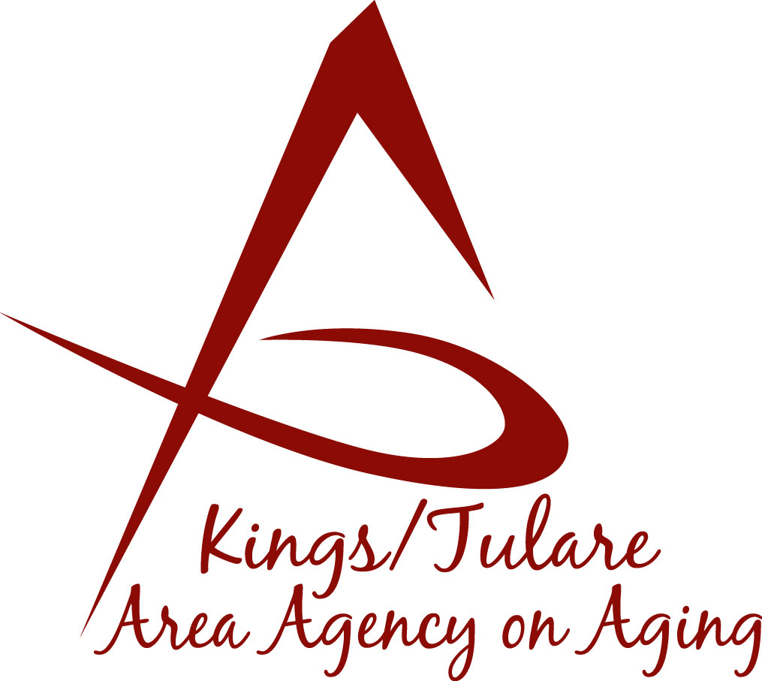
ADVISORY COUNCIL AGENDA
Monday, February 24, 2020
10:30 a.m.
Government Plaza Building
Pine North & South Conference Rooms
5957 S. Mooney Blvd
Visalia, CA 93291

- Call to Order Action

- Introductions of Guests and Council Members Information

3. Public Comment 3 minutes
Any person may directly address the Council at this time on any item on the Agenda or any other items of interest to the public that are within the subject matter jurisdiction of the K/TAAA.

4. Approval of Minutes Action
Members present at the previous meeting may comment or correct minutes from the meeting held on January 27, 2019.

5. Announcements and Correspondence Information

6. Milestone Updates Information
Information regarding current and former members of the Council

7. 2020 Schedule of Meetings: Dates and Locations Action

8. Letter to Council Member Grace Henn Action
Approval of letter declaring Seat # 14 vacant

9. Report from the ABC Committee Meeting Information
Feb 6, 2020 ABC Committee meeting with Matthew Kredit, Admin Specialist

10. Follow-Up Discussion on Proposed Schedule and Action
Composition Changes to the Council

11. Invitation to Kings/Tulare Ombudsman Mini-Conference Information
March 16, 2020 – Save the Date

12. Staff Reports Information

13. Development of the March 2020 Council Agenda Information

14. Additional Member Comments Information

15. Adjourn Action
If there is no further business to attend to, members may adjourn the meeting at this time.
Notice to the Public
In compliance with the Americans with Disabilities Act, if you need special assistance to participate in this meeting, please contact Christine Tidwell at (559) 624-8063.
The disclosable public records related to this agenda are available for public inspection at the reception area of the Tulare County Human Services Government Plaza building, 5957 S. Mooney Blvd. Visalia, CA 93277

