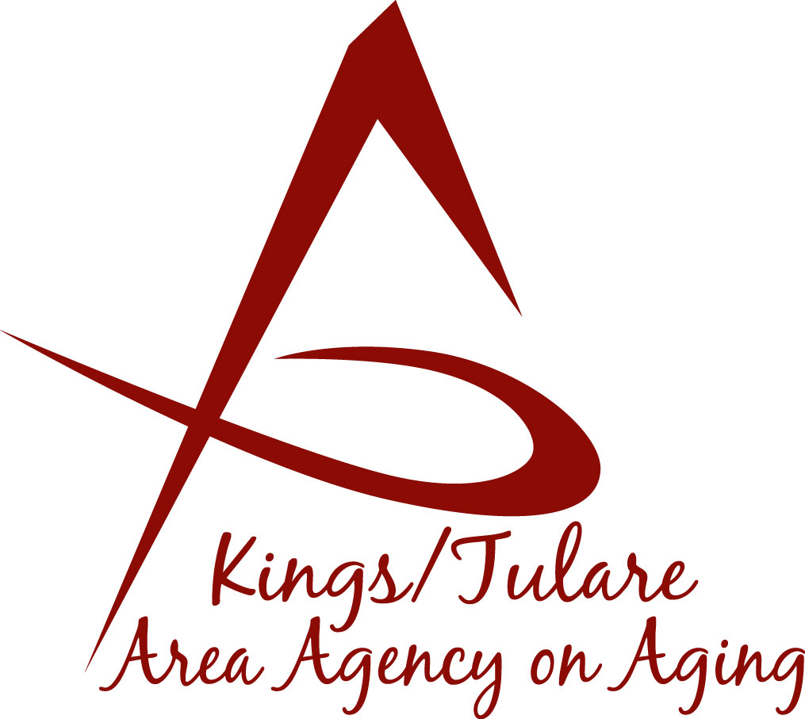ADVISORY COUNCIL AGENDA
Monday, August 19, 2019
10:30 a.m.
Government Plaza Bldg.
5957 S. Mooney Blvd.
RMA Conference Room, 1st Floor
Visalia, CA 93277

- Call to Order Action

- Introductions of Guests and Council Members Information

3. Public Comment 3 minutes
Any person may directly address the Council at this time on any item on the Agenda or any other items of interest to the public that are within the subject matter jurisdiction of the K/TAAA.

4. Approval of Minutes Action
Members present at the previous meeting may comment or correct minutes
from the meeting held on July 22, 2019.

5. Announcements and Correspondence Information

6. Milestone Updates Information
Information regarding current and former members of the Council

7. Update on CA Senior Legislature (CSL) Joint Rules Committee Action
(Dr. David Wood)

8. Brief Discussion on Mental Health bill AB 480 Information
(Dr. David Wood)

9. Final Review of the Annual Report Information/Action
For presentation to the Governing Board at its October 2019 meeting

10. Staff Reports Information

11. Pending Events Information

12. Development of the September 2019 Council Agenda Information

13. Additional Member Comments Information

14. Adjourn Action
If there is no further business to attend to, members may adjourn the meeting at this time.
Notice to the Public
In compliance with the Americans with Disabilities Act, if you need special assistance to participate in this meeting, please contact Christine Tidwell at (559) 624-8063.
The disclosable public records related to this agenda are available for public inspection at the reception area of the Tulare County Human Services Government Plaza building, 5957 S. Mooney Blvd. Visalia, CA 93277

