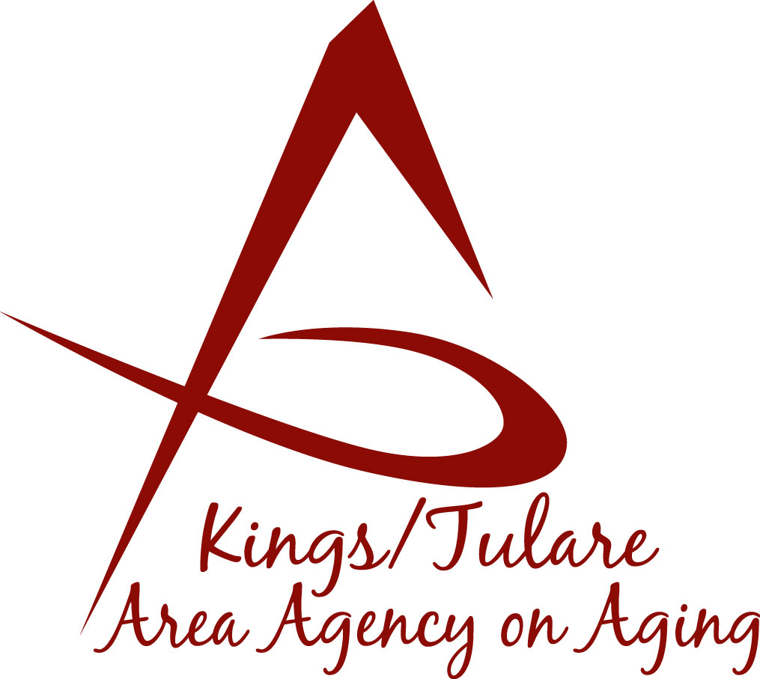 ADVISORY COUNCIL AGENDA
Monday, October 17, 2016
Meeting will begin at 10:30 a.m.
Avenal Senior Center
108 Kings Way
Avenal, CA 93204

- Call to Order

- Introductions

3. Public Comment 3 minutes
Any person may directly address the Council at this time on any item on the Agenda or any other items of interest to the public that are within the subject matter jurisdiction of the K/TAAA.

4. Approval of Minutes Action
Members present at the previous meetings may comment or correct minutes from the meetings held on September 26, 2016.

5. Announcements and Correspondence Information

6. Milestone Updates Information
Information regarding current and former members of the Council

7. Membership Committee (Marlene Chambers) Action
Recommendation of Candidate Steven A. Nelson

8. CA Area Agency on Aging (C4A) Information

9. California Senior Legislature (CSL) Information

10. K/T AAA Ombudsman Program (Maribel Martinez) Information
Presentation on the K/T AAA Ombudsman Program

11. Committee & Retreat Ideas Information
Continued discussion regarding Ethics Training, updating Bylaws, etc.

12. Staff Reports Information

13. Additional Member Comments Information

14. Adjourn Action
If there is no further business to attend to, member may adjourn the meeting at this time.

Notice to the Public
In compliance with the Americans with Disabilities Act, if you need special assistance to participate in this meeting, please contact Christine Tidwell at (559) 624-8063.

The disclosable public records related to this agenda are available for public inspection at the reception area of the Tulare County Human Services Government Plaza building, 5957 S. Mooney Blvd. Visalia, CA 93277

