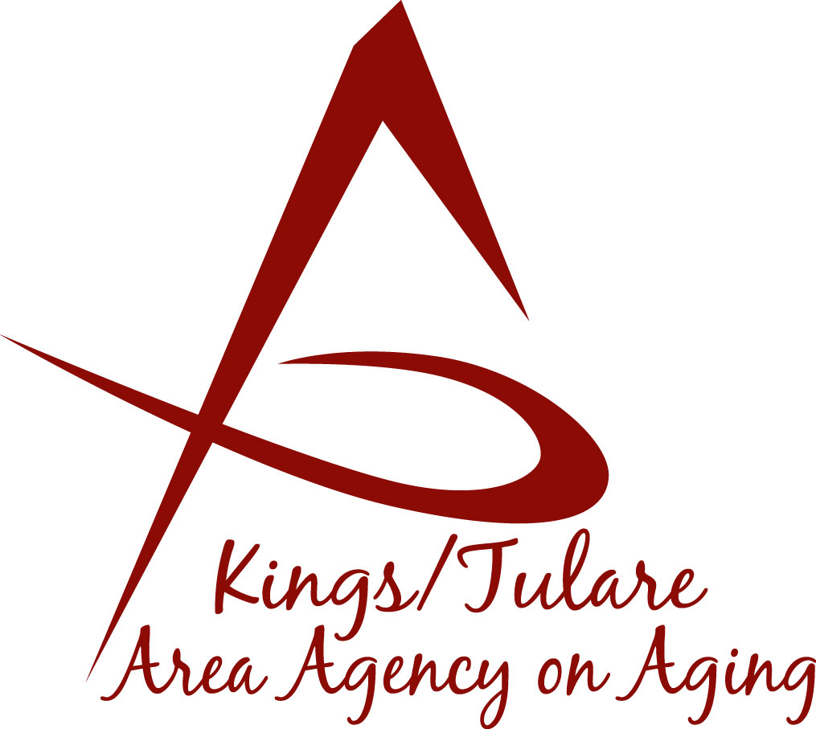ADVISORY COUNCIL AGENDA
Monday, May 15, 2017
10:45 a.m.
Earlimart Senior Center
712 East Washington Avenue
Earlimart, CA 93291

- Call to Order Action

- Introductions of Guests and Council Members Information

3. Public Comment 3 minutes
Any person may directly address the Council at this time on any item on the Agenda or any other items of interest to the public that are within the subject matter jurisdiction of the K/TAAA.

4. Approval of Minutes Action
Members present at the previous meetings may comment or correct minutes from the meeting held on April 19, 2017.

5. Announcements and Correspondence Information

6. Milestone Updates Information
Information regarding current and former members of the Council

7. Committees and Committee Assignments Information
- Transportation
- Area Plan/Budget/Contracts (ABC)
- California Senior Legislature (CSL)

8. Membership Recommendations (Kyle Melton) Action

9. Staff Reports Information

- Farmers Market coupons
- Senior Day Highlights

10. Development of June Council Agenda Information

11. Additional Member Comments Information

12. Adjourn Action
If there is no further business to attend to, members may adjourn the meeting at this time.
Notice to the Public
In compliance with the Americans with Disabilities Act, if you need special assistance to participate in this meeting, please contact Christine Tidwell at (559) 624-8063.
The disclosable public records related to this agenda are available for public inspection at the reception area of the Tulare County Human Services Government Plaza building, 5957 S. Mooney Blvd. Visalia, CA 93277

