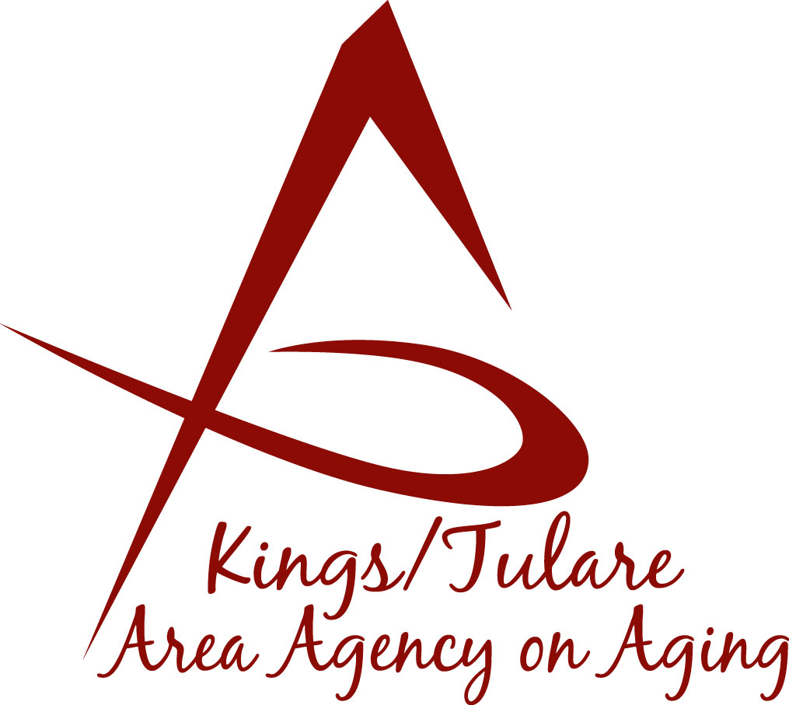 ADVISORY COUNCIL AGENDA
Monday, August 15, 2016
Meeting begins at 10:30 a.m.
Noble Plaza
4025 W. Noble Avenue, Suite A
Visalia, CA 93291

- Call to Order

- Introductions

3. Public Comment 3 minutes
Any person may directly address the Council at this time on any item on the Agenda or any other items of interest to the public that are within the subject matter jurisdiction of the K/TAAA.

4. Approval of Minutes Action
Members who were present at the previous meetings may comment
or correct minutes from the meetings held on July 18, 2016.

5. Announcements and Correspondence Information

6. Milestone Updates Information
Information regarding current and former members of the Council

7. Program Overview by K/T AAA Program Staff Information
- Health Insurance Counseling & Advocacy-HICAP (Dori Silveria)
- Multipurpose Senior Services Program (Rosalia Miller, RN, PHN)

8. Membership Recruitment (Kyle Melton/Marlene Chambers) Action
Recommendation of Candidate Bobbie Wartson-Kings County

9. Site Visits and Calendar of Events (Bonnie Quiroz) Information

10. Training Topics Information

11. Discussion of Committees/Committee Appointments Information

12. Development of Retreat Ideas Information

13. Staff Reports Information
- Holiday Stockings – 2016 Season (Nancy Aldaoud)
- K/T AAA Handbook- Project Status Update (Nancy Aldaoud)

14. Additional Member Comments Information

15. Adjourn Action
If there is no further business to attend to, member may adjourn the meeting at this time.
Notice to the Public
In compliance with the Americans with Disabilities Act, if you need special assistance to participate in this meeting, please contact Christine Tidwell at (559) 624-8063.

The disclosable public records related to this agenda are available for public inspection at the reception area of the Tulare County Human Services Government Plaza building, 5957 S. Mooney Blvd. Visalia, CA 93277

