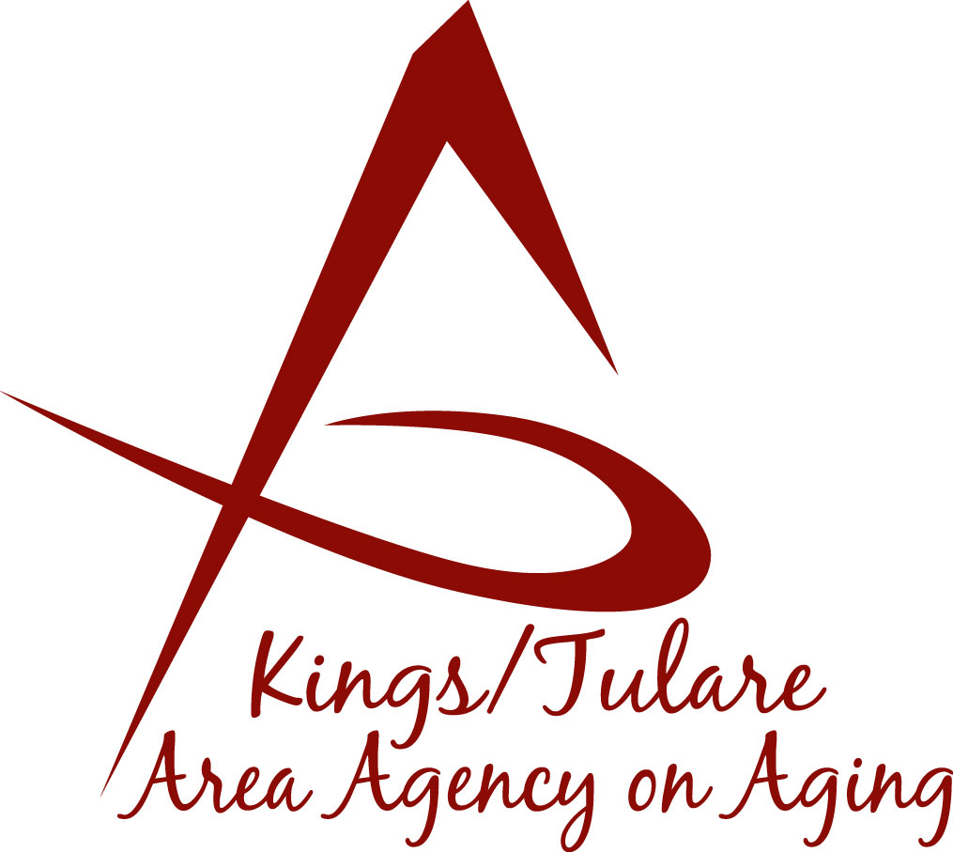ADVISORY COUNCIL AGENDA
Monday, August 21, 2017
Meeting begins at 10:30 a.m.
New Farmersville Senior Center
623 N. Avery Avenue
Farmersville, CA 93223

- Call to Order Action

- Introductions of Guests, Council Members and Seniors Information

3. Public Comment 3 minutes
Any person may directly address the Council at this time on any item on the Agenda or any other items of interest to the public that are within the subject matter jurisdiction of the K/TAAA.

4. Approval of Minutes Action
Members present at the previous meetings may comment or correct minutes from the meeting held on July 17, 2017.

5. Announcements and Correspondence Information

6. Milestone Updates Information
Information regarding current and former members of the Council

7. Introduction of New Aging Services Manager Information
Juliet Webb, K/T AAA Director

8. New Membership Candidate (Kyle Melton) Action
Vote to recommend Grace Henn for appointment

9. Kings County Food Distribution (Bobbie Wartson) Information

10. Homebound Brown Bag Project (Bonnie Quiroz) Information

11. Tour of Farmersville Senior Center (Albert Cendejas) Information

12. Staff Reports Information

13. Development of September Council Agenda Information

14. Additional Member Comments Information

15. Adjourn Action
If there is no further business to attend to, members may adjourn the meeting at this time.
Notice to the Public
In compliance with the Americans with Disabilities Act, if you need special assistance to participate in this meeting, please contact Christine Tidwell at (559) 624-8063.
The disclosable public records related to this agenda are available for public inspection at the reception area of the Tulare County Human Services Government Plaza building, 5957 S. Mooney Blvd. Visalia, CA 93277

