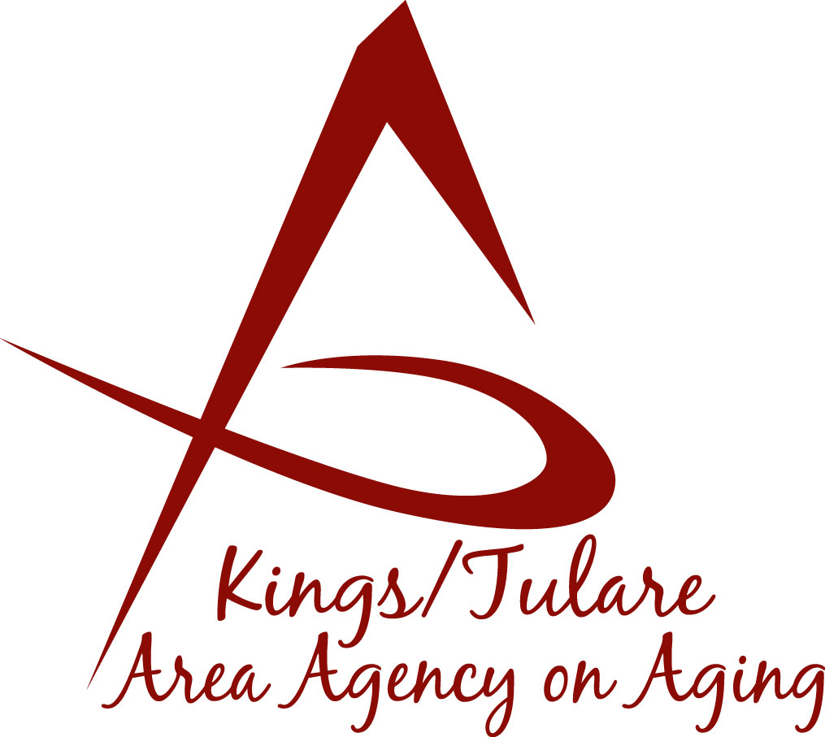ADVISORY COUNCIL AGENDA
Monday, November 19, 2018
11:00 a.m.
Tulare County Board of Supervisor’s Bldg.
Conference Rooms A/B
2800 W. Burrel Avenue
Visalia, CA 93291

- Call to Order Action

- Introductions of Guests and Council Members Information

3. Public Comment 3 minutes
Any person may directly address the Council at this time on any item on the Agenda or any other items of interest to the public that are within the subject matter jurisdiction of the K/TAAA.

4. Approval of Minutes Action
Members present at the previous meeting may comment or correct minutes from the meeting held on October 15, 2018.

5. Announcements and Correspondence Information

6. Milestone Updates Information
Information regarding current and former members of the Council

7. California Senior Legislature (CSL) Report Information
Ms. Bobbie Wartson & Dr. David Wood

8. California Association of Area Agencies on Aging (C4A) Information
Annual Mtg. and Allied Conference Report K/T AAA Staff

9. Advisory Council Annual Report Planning (Follow-Up) Information

10. Staff Reports Information

11. Development of the December 2018 Council Agenda Information

12. Additional Member Comments Information

13. Adjourn Action
If there is no further business to attend to, members may adjourn the meeting at this time.
Notice to the Public
In compliance with the Americans with Disabilities Act, if you need special assistance to participate in this meeting, please contact Christine Tidwell at (559) 624-8063.
The disclosable public records related to this agenda are available for public inspection at the reception area of the Tulare County Human Services Government Plaza building, 5957 S. Mooney Blvd. Visalia, CA 93277

