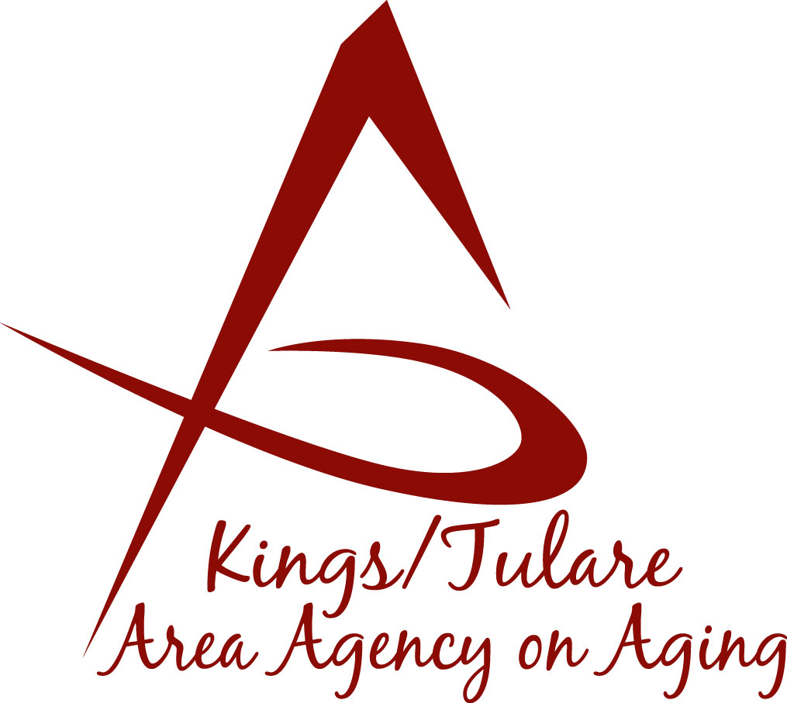ADVISORY COUNCIL AGENDA
Monday, May 14, 2018
11:00 a.m.
Cutler-Orosi Senior Center
12691 Ave 408
Cutler, CA 93615

- Call to Order Action

- Introductions of Guests and Council Members Information

3. Public Comment 3 minutes
Any person may directly address the Council at this time on any item on the Agenda or any other items of interest to the public that are within the subject matter jurisdiction of the K/TAAA.

4. Approval of Minutes Action
Members present at the previous meeting may comment or correct minutes from the meeting held on April 23, 2018.

5. Announcements and Correspondence Information

6. Milestone Updates Information
Information regarding current and former members of the Council

7. Older Americans Month Proclamation (May) Information
Tulare County Board of Supervisors Proclamation issued on May 8, 2018

8. California Senior Legislature (CSL) Election Action
CSL election by acclamation

9. Health Insurance Counseling and Advocacy Program Information
Presentation by the K/T AAA HICAP program

10. Triple-A Council of California (TACC) Information
Quarterly report for K/T AAA PSA 15

11. Staff Reports Information

12. Development of the June 2018 Council Agenda Information

13. Additional Member Comments Information

14. Adjourn Action
If there is no further business to attend to, members may adjourn the meeting at this time.
Notice to the Public
In compliance with the Americans with Disabilities Act, if you need special assistance to participate in this meeting, please contact Christine Tidwell at (559) 624-8063.
The disclosable public records related to this agenda are available for public inspection at the reception area of the Tulare County Human Services Government Plaza building, 5957 S. Mooney Blvd. Visalia, CA 93277

