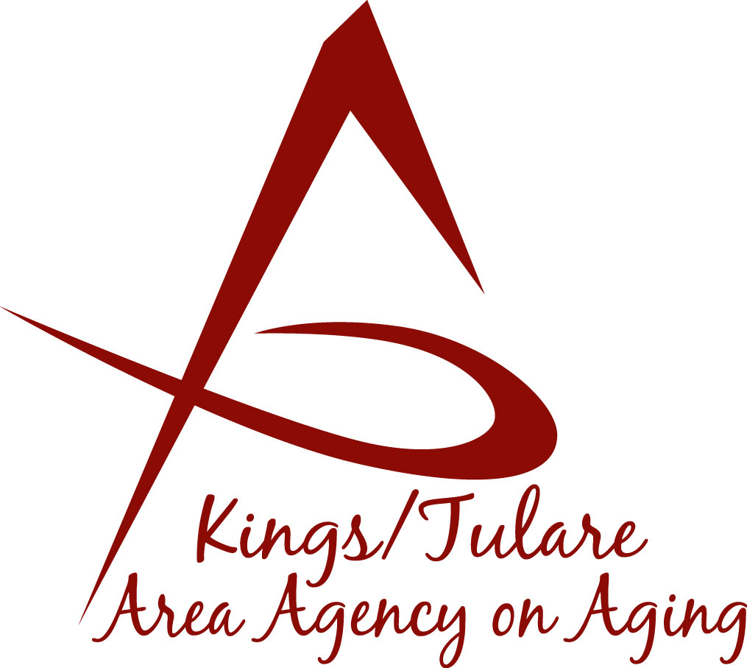 ADVISORY COUNCIL AGENDA
Monday, December 14, 2015
Meeting begins at 11:30 a.m.
Café 225
225 West Main Street
Visalia, CA 93291

- Call to Order

2. Public Comment 3 minutes
Any person may directly address the Council at this time on any item on the Agenda or any other items of interest to the public that are within the subject matter jurisdiction of the K/TAAA.

3. Approval of Minutes Action
Members who were present at the previous meetings may comment
or correct minutes from the meetings held on July 20, 2015. (October 2015 meeting cancelled; meetings held quarterly.)

4. Announcements and Correspondence Information

5. Milestone Updates Information
Information regarding current and former members of the Council

6. California Senior Legislature Update (Don Turner) Information

7. Report on C4A Annual Meeting and Allied Information

Conference (Don Turner/Sharon DeMasters)

8. K/T AAA Senior Holiday Stocking Project for the Information
Homebound (Laura Silva)

9. “Choose Joy” campaign benefits Senior Centers Information
(Laura Silva)

10. Presentation by Noah Whitaker, Community Information
Outreach Manager

11. Additional Member Comments Information

12. Adjourn Action
If there is no further business to attend to, member may adjourn the meeting at this time.

NEXT:

Governing Board Meeting
January 25, 2016
10:00 a.m.
Tulare County board of Supervisors
Conference Rooms A/B
2800 West Burrel
Visalia, CA 93291
*
Advisory Council Meeting
(Following the Governing Board meeting)
January 25, 2016
11:00 a.m.
Tulare County board of Supervisors
Conference Rooms A/B
2800 West Burrel
Visalia, CA 93291
Notice to the Public
In compliance with the Americans with Disabilities Act, if you need special assistance to participate in this meeting, please contact Christine Tidwell at (559) 624-8063.

The disclosable public records related to this agenda are available for public inspection at the reception area of the Tulare County Human Services Government Plaza building, 5957 S. Mooney Blvd. Visalia, CA 93277

