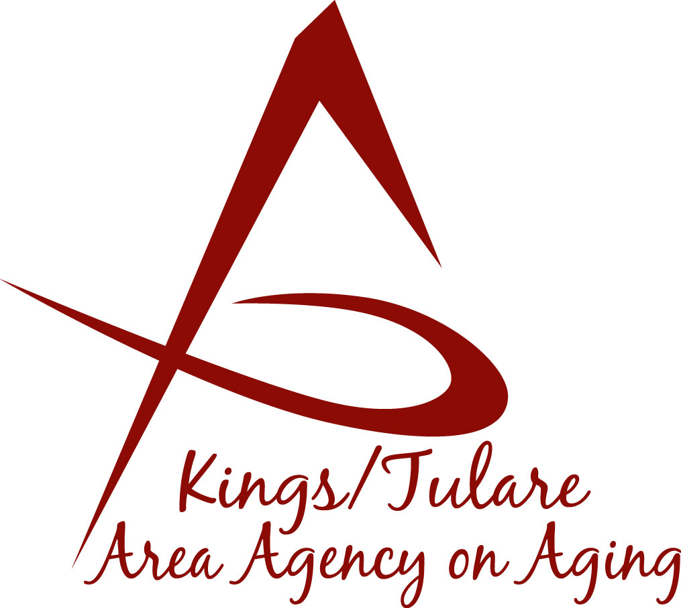ADVISORY COUNCIL AGENDA
Monday, April 23, 2018
10:30 a.m.
Porterville Senior Center
280 N. Fourth Street
Porterville, CA 93257

- Call to Order Action

- Introductions of Guests and Council Members Information

3. Public Comment 3 minutes
Any person may directly address the Council at this time on any item on the Agenda or any other items of interest to the public that are within the subject matter jurisdiction of the K/TAAA.

4. Approval of Minutes Action
Members present at the previous meeting may comment or correct minutes from the meeting held on February 12, 2018. February minutes require approval as there was no quorum for approval in March. (Notes will be distributed from March 19, 2018, but due to the lack of a quorum, it was not an officially-convened meeting.)

5. Announcements and Correspondence Information

6. Milestone Updates Information
Information regarding current and former members of the Council

7. Fair Political Practices Commission (FPPC) Information
Form 700, Statement of Economic Interest

8. Older Americans Month Proclamation (May) Information
Tulare County Board of Supervisor Proclamation on May 8, 2018

9. Senior Day in the Park Volunteer Opportunities Information
Registration Details

10. Multi-Purpose Senior Services Program (MSSP) Information
Presentation by the K/T AAA MSSP program

11. California Senior Legislature (CSL) Election Information Information
Notice of the upcoming CSL elections – set for May 2018

12. Staff Reports Information

13. Development of the May 2018 Council Agenda Information

14. Additional Member Comments Information

15. Adjourn Action
If there is no further business to attend to, members may adjourn the meeting at this time.
Notice to the Public
In compliance with the Americans with Disabilities Act, if you need special assistance to participate in this meeting, please contact Christine Tidwell at (559) 624-8063.
The disclosable public records related to this agenda are available for public inspection at the reception area of the Tulare County Human Services Government Plaza building, 5957 S. Mooney Blvd. Visalia, CA 93277

