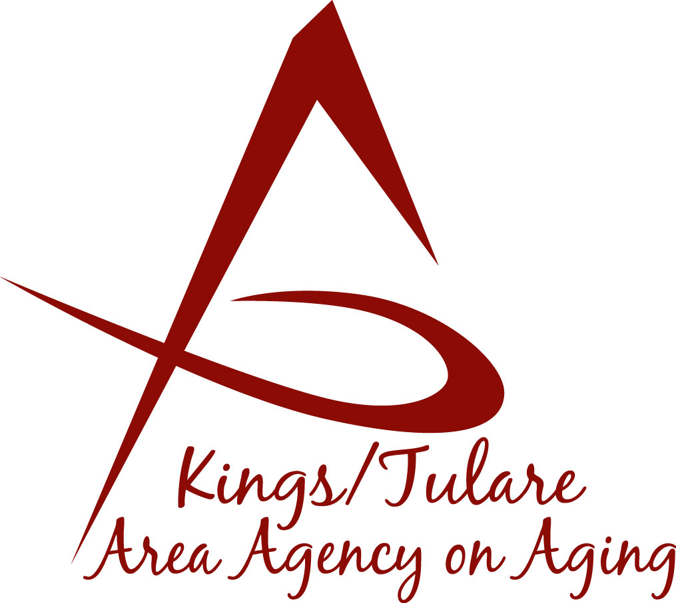ADVISORY COUNCIL AGENDA
Monday, October 16, 2017
Meeting to begin at 10:30 a.m.
Hanford Senior Center, View Road Apts.
602 9 ¼ Avenue
Hanford, CA 93230

- Call to Order Action

- Introductions of Guests and Council Members Information

3. Public Comment 3 minutes
Any person may directly address the Council at this time on any item on the Agenda or any other items of interest to the public that are within the subject matter jurisdiction of the K/TAAA.

4. Approval of Minutes Action
Members present at the previous meetings may comment or correct minutes from the meetings held on September 18, 2017.

5. Announcements and Correspondence Information

6. Milestone Updates Information
Information regarding current and former members of the Council

7. Report on the Triple-A Council of California Mtg. Information
(Dr. Wood, Chair) Information from the August TACC meeting in Sacramento

8 . CA Assoc. of Area Agencies on Aging (C4A) - Los Angeles Information
Opportunity for Advisory Council member to attend C4A meeting, Nov 14-16

9. California Senior Legislature (CSL) Participation Information
and Additional Committee Assignments and Discussion

10. Discussion of Candidate Nominations for Chair/Vice Chair Information
For December Elections

11. Staff Reports Information

12. Development of the October Council Agenda Information

13. Additional Member Comments Information

14. Adjourn Action
If there is no further business to attend to, members may adjourn the meeting at this time.
Notice to the Public
In compliance with the Americans with Disabilities Act, if you need special assistance to participate in this meeting, please contact Christine Tidwell at (559) 624-8063.
The disclosable public records related to this agenda are available for public inspection at the reception area of the Tulare County Human Services Government Plaza building, 5957 S. Mooney Blvd. Visalia, CA 93277

