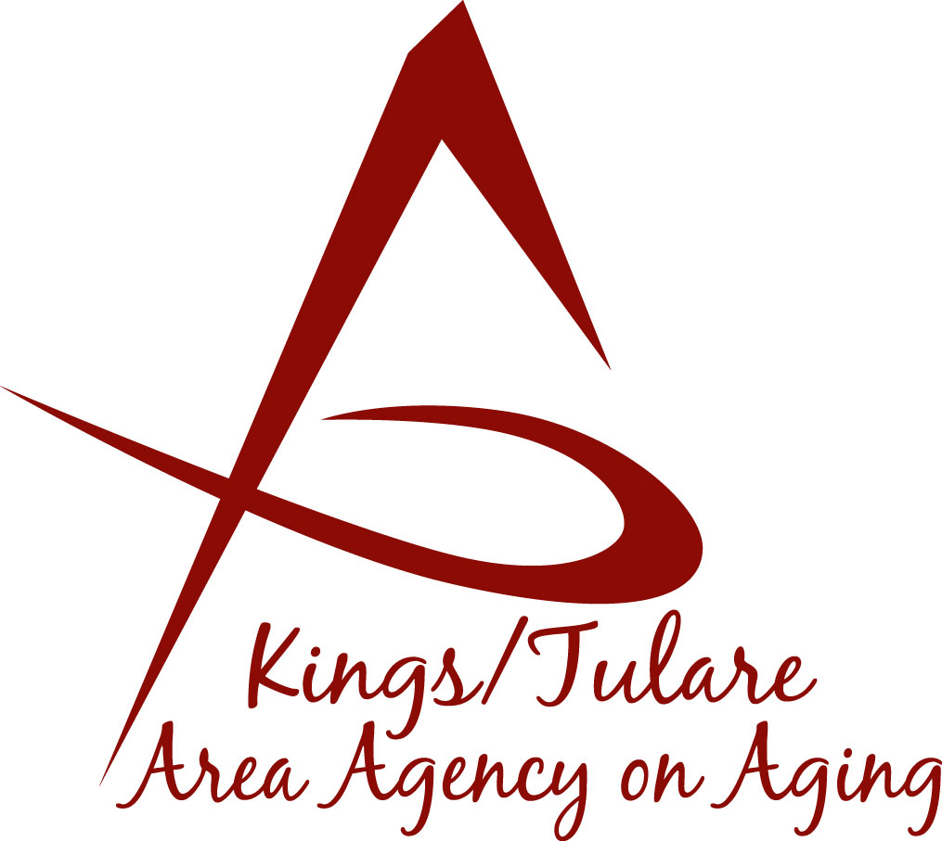ADVISORY COUNCIL AGENDA
Monday, December 18, 2017
Meeting begins at 11:00 a.m.
St. Anthony Retreat
43816 Sierra Drive/Hwy 198
Three Rivers, CA 93271

- Call to Order Action

- Introductions of Guests and Council Members Information

3. Public Comment 3 minutes
Any person may directly address the Council at this time on any item on the Agenda or any other items of interest to the public that are within the subject matter jurisdiction of the K/TAAA.

4. Approval of Minutes Action
Members present at the previous meetings may comment or correct minutes from the meetings held on November 20, 2017.

5. Announcements and Correspondence Information

6. Milestone Updates Information
Information regarding current and former members of the Council

7. K/T AAA Website Design (Israel Guardado) Information
Report on new plans, ideas, and possibilities for a redesign of ktaaa.org

8. CA Assoc. of Area Agencies on Aging (C4A) Information
Betsey Foote: Information from the C4A conference in Los Angeles

9. Presentation from the Suicide Prevention Task Force (SPTF) Information
Noah Whitaker: Coordinator of the SPTF & Community Outreach Manager

10. Staff Reports Information

11. Development of the January 22, 2018 Council Agenda Information

12. Additional Member Comments Information

13. Adjourn Action
If there is no further business to attend to, members may adjourn the meeting at this time.
Notice to the Public
In compliance with the Americans with Disabilities Act, if you need special assistance to participate in this meeting, please contact Christine Tidwell at (559) 624-8063.
The disclosable public records related to this agenda are available for public inspection at the reception area of the Tulare County Human Services Government Plaza building, 5957 S. Mooney Blvd. Visalia, CA 93277

