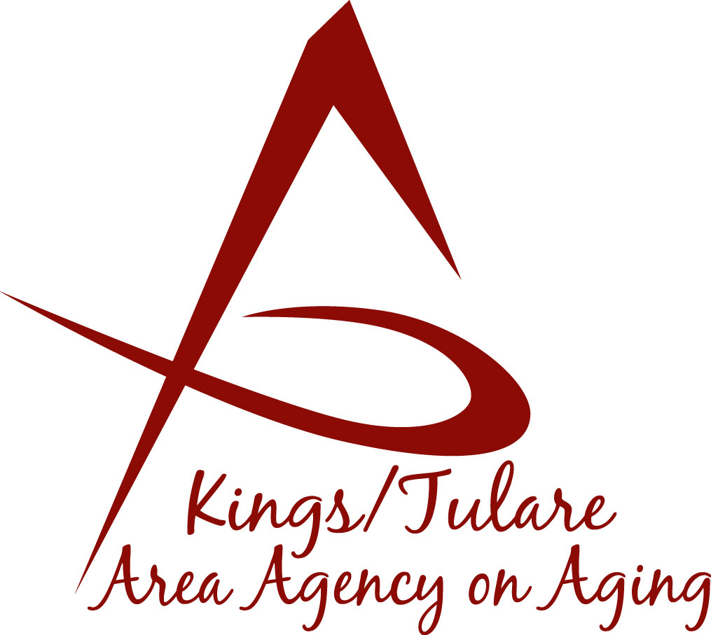
KINGS/TULARE AREA AGENCY ON AGING
ADVISORY COUNCIL
5957 S. Mooney Boulevard
Visalia, California 93277-9394
559-624-8063

KINGS/TULARE AREA AGENCY ON AGING ADVISRORY COUNCIL RETREAT
AGENDA

Date and Time: March 20, 2017
Location: Tulare County Board of Supervisors
- Burrel Ave, Conference Room A/B, Visalia, CA

- Call to order 11:00 am

NOTICE TO THE PUBLIC
PUBLIC COMMENT PERIOD
At this time any person may directly address the Council on any item on the agenda or any other items of interest to the public that are within the subject matter jurisdiction of the K/T AAA. Any person addressing the Board will be limited to a maximum of three (3) minutes so that all interested parties have an opportunity to speak. At all times, please state your name and address for the record.

- Public Comment 11:00 - 11:05 am

- Introductions - Guests and Council Members 11:05 - 11:10 am

- Approval of Minutes Action
Members present at the previous meetings may comment or correct minutes from the meetings held on January 23, 2017.

- Announcements and Correspondence Information

- K/T AAA Advisory Council Orientation (Matthew Kredit and Israel Guardado) 11:10 a.m. – 12:30 pm
  - Overview of K/T AAA – Powerpoint and Binder Review

  - Questions and Answers

LUNCH 12:30 - 1:00 pm

7. Council Priorities, Goals, and Expectations 1:00 - 3:30 pm
- Discuss and Identify Key Topics of the Council’s Interest

- Report on Suggestions and Recommendations from Agencies and HHSA Branches (Dr. Wood)

- Establish Committees and Committee Assignments

- Participation in California Groups Involved with Aging & the Elderly, i.e., C4A, CSL, CWDA, etc.

- Additional Comments

- Adjournment 3:30 p.m.

In compliance with the Americans with Disabilities Act, if you need special assistance to participate in this meeting,
please contact Christine Tidwell at 624-8063.
Public documents related to the items on this agenda may be reviewed at the reception counter in the lobby of
Tulare County Government Plaza, 5957 South Mooney Boulevard, Visalia, CA 93277.

