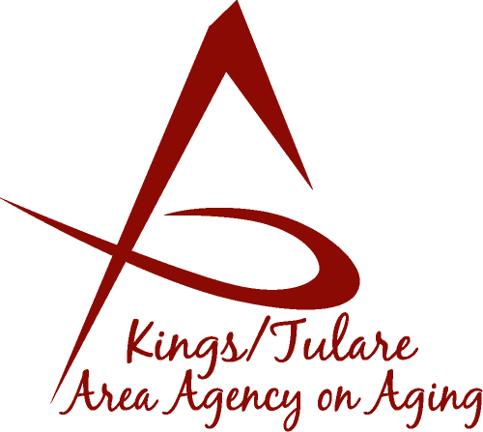 ADVISORY COUNCIL MINUTES

(of) July 20, 2015
Professional Development Center (PDC)
4031 W. Noble Avenue
Visalia, CA 93277

MEMBERS PRESENT:
Marlene Chambers
Sharon DeMasters m
Marsha Calhoun
Dick Johnson
Kyle Melton
Grace Schraa
Cheri Taylor
Don Turner
Dr. David Wood
Maggie Woodhouse
Suzann Wray
Mary Krieg-Vasquez

MEMBERS ABSENT:
Fern Haller
Sharon Lamagno
Suzann Wray
Ben Cordova

GUESTS & ALTERNATES PRESENT:
Patricia Castro-Ridenour, RSVP Program
Albert Cendejas, CSET

STAFF PRESENT:
Laura Silva, K/T AAA Director
Brooke Sisk, Administrative Specialist
Armida Quezada, HICAP presenter
Christine Tidwell, Administrative Aide

- Call to Order – Sharon DeMasters, Chair, called the meeting to order at11:06 a.m.

- Public Comments – No public comment.

- Approval of Minutes – Marlene Chambers motioned to accept the minutes of the May 18, 2015; Council meeting. Kyle Melton seconded the motion and the minutes were approved unanimously.

- Announcements and Correspondence
Sharon DeMasters announced that Friday, September 18, 2015, (9 a.m. to 2 p.m.), will be the date and time of the Kings County Senior Day in the Park. The location is Burris Park. Those interested in helping with the event registration can let her know.

Christine Tidwell announced that the next Advisory Council on October, 19, 2015, will be at the Corcoran Senior Center, which is about an hour’s travel time. The K/T AAA staff will be driving there, so if anyone wishes to go along with staff they are welcome. A Governing Board meeting will also be at the same location on that day, just prior to the Advisory Council meeting.

- Milestone Updates – Christine Tidwell reported that she had spoken to Council member, Fern Haller, who is recovering from injuries incurred earlier in a fall. Ms. Haller was planning to attend today’s meeting but became ill from an unrelated cause.

Dr. Wood reported that he has been elected as First Vice President to the California Association of Local Mental Health Boards and Commissions, so that means that we are potentially more connected if we wish to be in terms of California mental health issues. Each county in California has an advisory board.

Cheri Taylor announced that Porterville Adult Day Services is celebrating being in operation for 25 years. Ms. DeMasters said that the KCCOA Lemoore Daycare will also be celebrating its 25 years.

- California Senior Legislature (CSL) Update – Don Turner gave an update on the CSL. Two CSL proposals are coming up for hearings. The CSL is asking for letters of support. The proposals are: AB139 for non-probate transfers - revocable transfers upon death deeds, which would transfer real property on the death of its owner without a probate proceeding, according to specified rules. It will be heard August 17, 2015 at the Committee of Appropriations. Letters of support need to be submitted by August 10, 2015.

AB1235 is regarding Medi-Cal bill beneficiary needs. It establishes eligibility and other requirements for providing a home upkeep allowance for transitional and personal needs.

Council member Mary Krieg-Vasquez asked what the procedure is for submitting a support letter and is there a template for the support letter? Mr. Turner said he did not have a template, but he had the names of the Committee Senators. It was decided that, individually, anyone who wished to, could write a letter of support, but not as a voice of the Council.

Dr. Wood suggested it would be better to have numerous letters from individuals. Additionally, he said as a Board or Council caution should be exercised in taking a “pro or con” position.

Mr. Turner said another bill that the CSL is following is the Death with Dignity bill, now called, the End of life Option Act, which is currently stalled in the Assembly Committee on Health.

Mr. Turner said Kings County is looking at developing a pilot project for in-home care for the typical aging person (versus an IHSS clients) - looking at automated systems that can assist a person after the caregiver leaves.

Also being discussed is a proposal for coverage under Medicare of certain drugs used for erectile dysfunction.

- Report on TCAG Transportation Meeting – Albert Cendejas reported on the first of several informational meetings on how organizations can link with service providers in Tulare County and with community leaders, regarding Section 5310, which is aimed at enhancing mobility for seniors and individuals with disabilities, including the buying of buses and vans, lifts, etc., and other hardware needed to transport disabled persons. Also discussed: applying for vouchers for seniors and the disabled. More details will be offered at the following meetings.

- Report on the White House Conference on Aging – Don Turner reported on the White House Conference on Aging. This White House Conference meets every 10 years. The focus of this conference was acknowledging and embracing the changing demographics of the aging population, and how government can work with the private sector to create opportunities for older Americans. Additionally, there was discussion of how multiple generations can stay connected, strategies for taking part in healthy activities, being involved in the community, and how new technology has changed the aging experience.

- Health Insurance Counseling & Advocacy Program (HICAP) – HICAP Counselor, Armida Quezada, gave an overview of the HICAP program, how it works, and its purpose.

- Adjourn – Meeting ended 12:37 p.m.

NEXT:

Governing Board Meeting
January 25, 2016
10:00 a.m.
Tulare county Board of Supervisors
2800 W. Burrel
Visalia, CA 93291
*
Advisory Council Meeting
January 25, 2016
(following the Governing Board Meeting)
10:30 a.m.
Tulare county Board of Supervisors
2800 W. Burrel
Visalia, CA 93291

