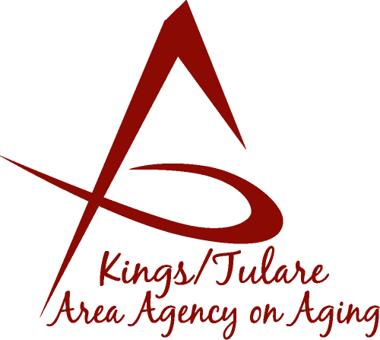 ADVISORY COUNCIL MINUTES

(of) December 14, 2015
225 West Main Street
Visalia, CA 93291

MEMBERS PRESENT:
Marlene Chambers
Sharon DeMasters m
Marsha Calhoun
Benjamin Cordova
Dick Johnson
Sharon Lamagno
Kyle Melton
Grace Schraa
Don Turner
Dr. David Wood
Maggie Woodhouse

STAFF PRESENT:
Laura Silva, K/T AAA Director
Christine Tidwell, Administrative Aide
Nancy Aldaoud, Administrative Aide
Bonnie Quiroz, Advocate
Maria Gonzalez, Social Services
MEMBERS ABSENT:
Fern Haller
Mary Krieg-Vasquez
Cheri Taylor
Suzann Wray

GUESTS & ALTERNATES PRESENT:
Albert Cendejas, CSET
Bobbie Wartson (KCCOA)
Barbara Melton,
Marlene Johnson

- Call to Order – Sharon DeMasters, Chair, called the meeting to order at11:48 a.m.

- Public Comments – Introductions were made by all in attendance. Christine Tidwell thanked the Council member for their participation in the Area Plan needs assessment survey. The needs assessment is a requirement for the development of the Area Plan.

- Approval of Minutes – Marlene Chambers motioned to accept the minutes of the July 20, 2015, Council meeting. Maggie Woodhouse seconded the motion and the minutes were approved unanimously.

- Announcements and Correspondence –
Laura Silva, K/T AAA Director announced that Brooke Sisk, the K/T AAA Administrative Specialist, has left the agency, and is now working with Tulare County General Services. Ms. Silva said she wished to acknowledge all the work and passion that Ms. Sisk contributed to the K/T AAA while she worked for the program. Matthew Kredit has been hired into the position. Additionally, a new Staff Services Analyst will also be starting with the Agency. Further, Ms. Silva introduced Nancy Aldaoud, who has joined K/T AAA as an Administrative Aide, and Maria Gonzalez, who is a K/T AAA Social Worker.

Sharon DeMasters, Council Chair, read the resignation letter of long-time Council member Cheri Taylor, who has decided to resign at the end of her term, on December 31, 2015.

- Milestone Updates – No milestone updates to report.

- California Senior Legislature (CSL) Update – Don Turner, CSL Senator reported that the CSL wrapped up its 35th annual legislative session on October 29, 2015. This is the first year the conference has been conducted as a tele-conference. Next year’s top 10 legislative priorities have been chosen for the new legislative session, with a focus on elder abuse prevention and the expansion of the Affordable Care Act. The CSL is a volunteer organization and does not receive any State funding. It operates on voluntary contributions.. Mr. Turner noted that the Governor signed the CSL sponsored, Right to Die, bill.

- Report on C4A Annual Meeting and Allied Conference – Ms. DeMasters said she sat in on many of the financial sessions at the C4A meeting, explaining what the State is expecting, not just from Area Agencies, but also what is expected of contractors. She also sat in on the Meals on Wheels (Home-Delivered Meals) sessions, and some of the Behavioral Health conversations. On issue she said she had written her congressperson regarding, was the suggestion of cutting the HICAP program - because she said she is aware how important the program is for seniors that need help finding affordable supplemental insurance. She said as we focus in on the senior services we do need to let the legislature hear our voices (advocacy).

Don Turner, who also attended the meeting, commented that the best part of the sessions was the opening session entitled, “Just Hang Up”. A Southern California acting troupe made up of seniors presented skits to convey the message to be award of scams. He noted one of the current prevalent scams is placing bogus calls from the IRS requesting money. The skit message was to, “Just Hang Up”. He also said he sat in on a Medicare Fraud session, which was an eye-opener on how much Medicare fraud takes place - with an estimated 6 to 90 billion dollars in fraudulent claim activity, including pharmacies short changing customers on the number of pills dispensed with a prescription.

- K/T AAA Senior Holiday Stocking Project for the Homebound – Laura Silva reported that the K/T AAA was excited this year it was able to do the Stocking drive for the home-bound seniors, including the Home-Delivered Meals (Tulare Co.) clients and the MSSP program clients (Kings and Tulare Co.), as well as Adult Protective Services and the Public Guardian program clients. The project allows for a home visit for the seniors who don’t have many visitors and are often isolated. This year’s target goal was approximately 400 stockings, with a total distributed of 360. This year, through the non-profit organization, Friends of Tulare, the K/T AAA could accept monetary and in-kind donations. Additionally, CSET was able to leverage donations through local packing houses and businesses, including Target, Odwalla, and Wonderful, Hobby Lobby, Kaweah Delta and Town Meadows housing, etc.

Additionally, the actual deliver of the stockings to the seniors was done in large part by Tulare County employees volunteering their time. She said it was a very successful campaign, noting that many connects made during this year’s campaign will be continuing into next year’s holiday season also.

Ms. DeMasters reported that Kings County distributed gifts to 40 Home-Bound Meals clients, with each getting a $20 gift card from Wal-Mart.

- Choose Joy Campaign Benefits Senior Centers – Ms. Silva reported that St. Paul’s school students in Visalia desired to raise funds and do something nice for the local senior centers, (as an 8th grade project). The project, entitled, Choose Joy, was the idea of helping to spread joy in the community. The project idea was to “sell” poinsettias that could then be donated to the senior centers. Albert Cendejas and Ms. Silva went to accept the plants from the students on behalf of the senior centers in Kings County and Tulare County.

- Presentation by Noah Whitaker, Community Outreach Manager – Mr. Whitaker gave a presentation on the Suicide Prevention Task Force and its activities, intervention strategies, and purpose. The task force is fully funded by Proposition 63, the Mental Health Services Act. Council member, Dr. David Wood, commented that it is a rare event in the State of California that there are these inter-county collaborative relationships and the Mental Health Services Oversight and Accountability Commission (MHSOAC) is looking at the activity, so it would be helpful if Council members log on to the Suicide Prevention Task Force website for information and to demonstrate interest and support.

- Additional Member Comments – Christine Tidwell reminded Council members that on January 25, 2016, there is an Advisory Council and Governing Board meeting scheduled.

- Adjourn – Meeting ended 1:13 p.m.

