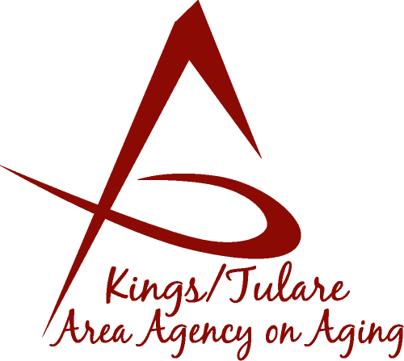 ADVISORY COUNCIL MINUTES

(of) August 15, 2016
4025 West Noble Avenue, Suite A
Visalia, CA 93277
*No quorum for this meeting; these are notes on the discussion.

MEMBERS PRESENT:
Dr. David Wood
Marlene Chambers m
Marsha Calhoun
Alicia Garcia

STAFF PRESENT:
Laura Silva, K/T AAA Director
Matthew Kredit, Administrative Specialist
Nancy Aldaoud, Administrative Aide
Bonnie Quiroz, Tulare Co. Client Advocate

MEMBERS ABSENT:
Benjamin Cordova
Mary Krieg-Vasquez
Sharon Lamagno
Kyle Melton
Grace Shraa
Maggie Woodhouse

GUESTS & ALTERNATES PRESENT:
Albert Cendejas, CSET
Bobbie Wartson, KCCOA Interim Director
Dori Silveria, HICAP
Rosalia Miller, MSSP
Esperanza Hansen
Steve Nelson, Mayor, City of Visalia
Martha Widmann
Elizabeth Holliday

- Call to Order – Dr. David Wood, Chair, called the meeting to order at 10:38 a.m.

- Introductions – Introductions were given by Council members, staff, and guest attendees.

- Public Comments – Dr. Wood, Chairman, said that because there were not enough Council members in attendance for a quorum, no actions could be voted upon; therefore, it was decided to hold over any action items until the next Council meeting. However, non-action items were discussed.

- Approval of the Minutes – Due to lack of a quorum, the minutes were not approved at this time, and will be an action item for the next meeting.

- Announcements and Correspondence – Dr. Wood noted that a letter had been received from Advisory Council member Grace Sharaa to let the Council know she will temporarily not be able to attend meetings, but would like to remain on the council.

Dr. Wood also mentioned the passing of Advisory Council member Don Turner.

Chairman Wood encouraged potential members to complete the member application form and he also stated that it is important to invite and encourage active community members to attend the meetings.

Laura Silva and Dr. Wood reported that an updated K/T AAA Orientation Manual is being created and revisions are currently underway.

Dr. Wood distributed the Mental Health Guidelines for presenters. This is a tool for presenters to be used when presenting information to the Advisory Council, in part, so speakers are more aware of what kind of information the Council is looking for or may need.

- Milestone Updates – It was reported that former Council members, Carla Treuting & Fern Haller had received visits from the K/T AAA Client Advocate, Bonnie Quiroz, who reported they are both doing very well.

- Program Overview by K/T AAA Program Staff – The K/T AAA program staff reported on information regarding the Health Insurance Counseling and Advocacy Program (HICAP), and the Multipurpose Senior Services Program (MSSP). Dori Silveria, HICAP Manager spoke about the HICAP program and the ways this program serves and benefits the senior community. Rosalia Miller presented information about the MSSP program, its purpose, and how it is beneficial to the senior community.

- Membership Recruitment – Dr. Wood spoke about the progress in membership recruitment. Potential members were invited and encouraged to complete applications. There are currently three vacancies for Tulare County seats and one vacancy a Kings County seat. Bobbie Wartson, the KCCOA Interim Director expressed interest in becoming a Council member and has submitted an application.

- Site Visits and Calendar of Events – Bonnie Quiroz, the Elder & Dependent Adult Family Advocate for Aging Services in Tulare County invited Council members to come with her (shadowing her) when she visits the Senior Center sites. She presented a schedule of visiting dates as well as a calendar of events. The goal of this process is to bring the Advisory members to different senior sites in order to be introduced to the clients we serve, observe the services K/T AAA offers, and to create a stronger link between the seniors and the Council.

- Training Topics – This topic will be continued at a future meeting.

- Discussion of Committees/Committee Appointments – This topic will be continued at a future meeting.

- Development of Retreat Ideas – This topic also will be continued at a future meeting

- Staff Reports – K/T AAA staff reported on the updates to the K/T AAA manual, as well as the Stockings for Seniors holiday drive. Nancy Aldaoud reported the update on the handbook/manual is underway, with all documents, organizational charts, etc., being updated to the most recent versions.

Nancy Aldaoud also commented that the Stockings for Seniors committee has their first meeting and planning is underway for this year’s campaign. The collection of donations will soon begin with important dates and information to be decided at future meetings. Laura Silva explained to the attendees the reason and goal of the Senior Stockings Drive and the criteria for seniors to receive a holiday gift stocking.

- Additional Member Comments – Council member, Marlene Chambers mentioned The Kings County Commission on Aging (KCCOA) is scheduled to have their Senior Day on Friday, September 16, 2016. The theme of this year’s event is, All Around the World In a Day.

- Adjourn– The meeting was adjourned at 12:09 p.m.

