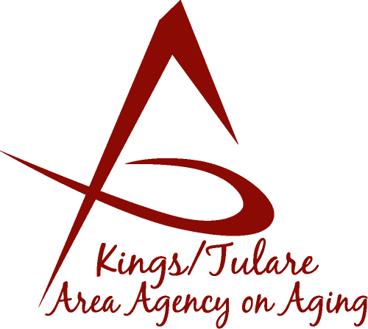 ADVISORY COUNCIL MINUTES

(of) April 25, 2016
2800 W. Burrel Avenue
Visalia, CA 93291

MEMBERS PRESENT:
Marlene Chambers
Sharon DeMasters m
Marsha Calhoun
Dick Johnson
Mary Krieg-Vasquez
Ben cordova
Kyle Melton

MEMBERS ABSENT:
Dr. David Wood
Fern Haller
Sharon Lamagno
Don Turner
Maggie Woodhouse
Grace Schraa
Suzann Wray
STAFF PRESENT:
Laura Silva, K/T AAA Director
Christine Tidwell, Administrative Aide
Nancy Aldaoud, Administrative Aide

GUESTS & ALTERNATES PRESENT:
Albert Cendejas, CSET
Alicia Garcia
Lorraine Zorn

- Call to Order – Sharon DeMasters, Chair, called the meeting to order at11:30a.m. No quorum for business. This will be an informational meeting only. No actions will be taken.

- Introductions – Introductions took place of attendees.

- Public Comments
- Albert Cendejas reported on the tie up of the 2016 season of Volunteer Income Tax Assistance (VITA) free tax preparation services.

- Approval of Minutes – No quorum for approval of minutes for the December 2015 and January 25, 2016 meetings. Action postponed until the next meeting.

- Announcements and Correspondence – Notice was made that member Dick Johnson is resigning off the Council as of the end of April.

It was noted that the Senior Farmers Market Coupons have been received from the CA Department of Food and Agriculture for the 2016 season.

- Milestone Updates – None. Appreciation was given to Christine Tidwell for her service with the K/T AAA and the Council.

- Election of Chair – Postponed due to lack of quorum.

- Membership Committee – Postponed due to lack of quorum.

- Fair Political Practices Commission (FPPC) – Form 700 is the Statement of Economic interest which Council members complete. Christine Tidwell requested any member that had not submitted his or her Form 700, to please do so as soon as possible.

- 2016 Schedule of Meetings – An updated meeting schedule with revised locations for the Governing Board (and Advisory Council which mirrors the Board schedule) was distributed.

- Discussion and Review of Committee Appointments – This item also on hold until the next meeting due to the absence of too many Council members.

- Area Plan – The Area Plan was distributed for review. It is important for the Council to be familiar with the Plan. The Plan has gone out to Public Hearing. It will go to the Governing Board in May for approval and authorization to send it to the State.

- Staff Reports – A brief report on the preparations for the Senior Day in the Park (May 6) was given by Laura Silva. (A more extensive update had been reported out at the Governing Board). She commented that the Opening Ceremony is scheduled to begin at 9:30 this year.

An award was presented to retiring member Dick Johnson for her years of service.

- Additional Member Comments – No further comments.

- Adjourn – Meeting ended 11:01 a.m.

