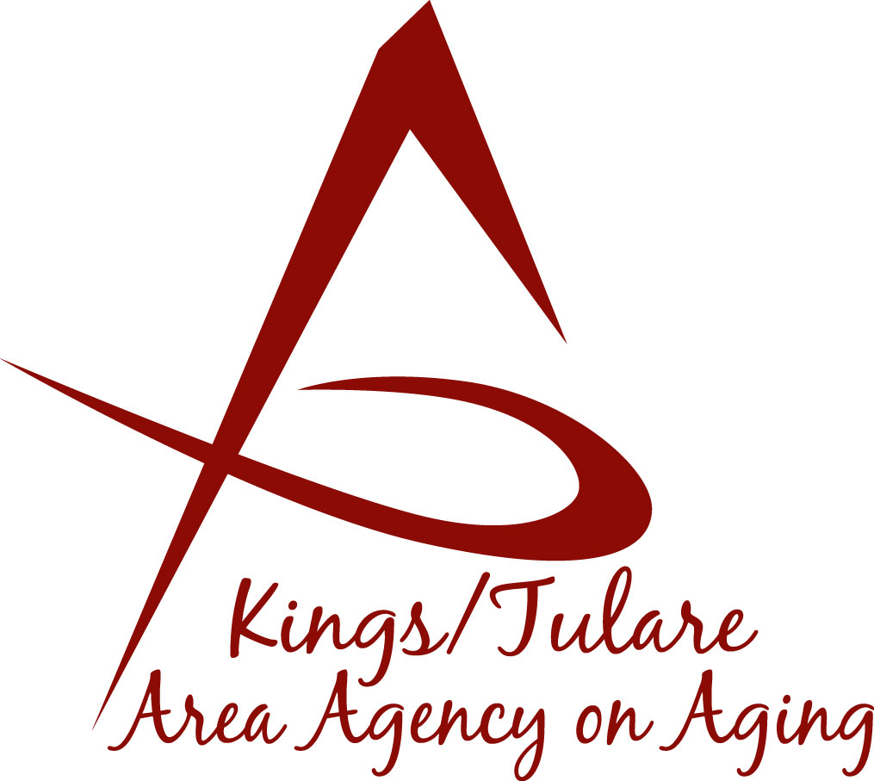
ADVISORY COUNCIL AGENDA
Monday, October 16, 2023
10:45 a.m.
Cutler Senior Center
Ledbetter Park
12691 Avenue 408
Cutler, CA 93615

- Call to Order Action

- Introductions of Guests and Council Members Information

- Public Comment 3 minutes
Any person may directly address the Council at this time on any item on the agenda or any other items of interest to the public that are within the subject
matter jurisdiction of the K/TAAA.

- Approval of Minutes Action
Members present at the previous meeting may comment or correct minutes from the meeting held on July 17, 2023.

- Announcement and Correspondence Information

6. Milestone Updates Information
Information regarding current and former members of the Council

7. Committee Matters Information/Action
Review and re-establish Committees, as needed, for ongoing business
- Membership
- Election/Nominations
- Chair nominations

8. Discuss Ideas for a December Meeting Information

9. Staff Reports Information

10. Development of the December 2023, Council Agenda Information

11. Additional Member Comments Information

12. Adjourn Action
If there is no further business to attend to, members may adjourn the meeting at this time.
Notice to the Public
In compliance with the Americans with Disabilities Act, if you need special assistance to participate in this meeting, please contact Christine Tidwell at (559) 624-8063.
The disclosable public records related to this agenda are available for public inspection at the reception area of the Tulare County Human Services Government Plaza building, 5957 S. Mooney Blvd. Visalia, CA 93277 *For Zoom tele-conference link information call: 559-624-8063.

