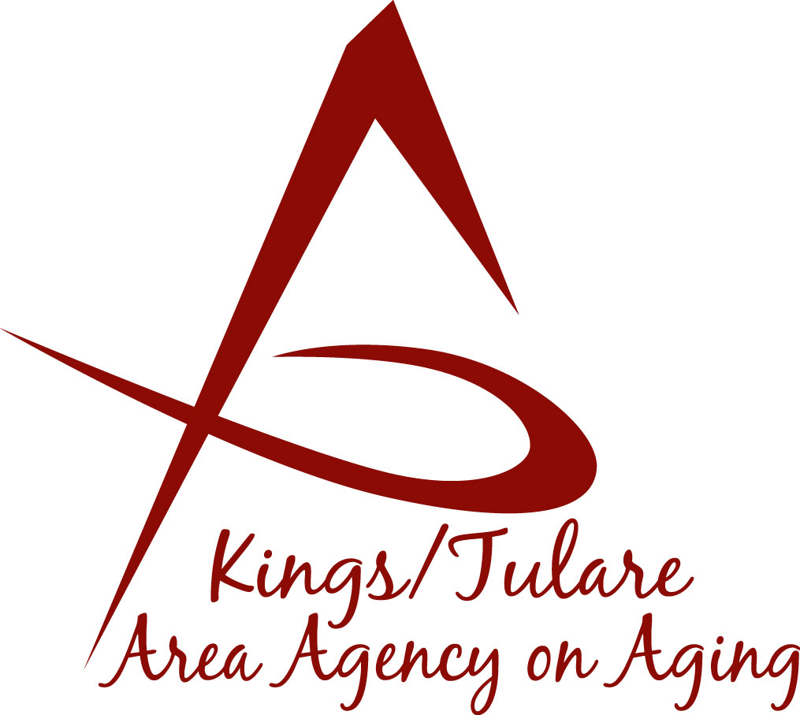
ADVISORY COUNCIL AGENDA
Monday, May 15, 2023
10:45 a.m.

Corcoran Senior Center
800 Dairy Drive
Corcoran, CA 93212
This meeting will be an in-person meeting.

- Call to Order Action

- Introductions of Guests and Council Members Information

- Public Comment 3 minutes
Any person may directly address the Council at this time on any item on the agenda or any other items of interest to the public that are within the subject
matter jurisdiction of the K/TAAA.

- Approval of Minutes Action
Members present at the previous meeting may comment or correct minutes from the meeting held on March 20, 2023.

- Announcement and Correspondence Information

6. Milestone Updates Information
Information regarding current and former members of the Council

7. Recommendation to Move Applicant’s Name Forward Action
For Appointment (Bobbie Wartson)

8. Staff Reports Information
- Report on Area Plan – (Finalized at the Governing Board meeting)
- Recommendations regarding the Request for Proposals (RFP)
- Other

9. Development of the July 2023, Council Agenda Information

10. Additional Member Comments Information

11. Adjourn Action
If there is no further business to attend to, members may adjourn the meeting at this time.
Notice to the Public
In compliance with the Americans with Disabilities Act, if you need special assistance to participate in this meeting, please contact Christine Tidwell at (559) 624-8063.
The disclosable public records related to this agenda are available for public inspection at the reception area of the Tulare County Human Services Government Plaza building, 5957 S. Mooney Blvd. Visalia, CA 93277 *For Zoom tele-conference link information call: 559-624-8063.

