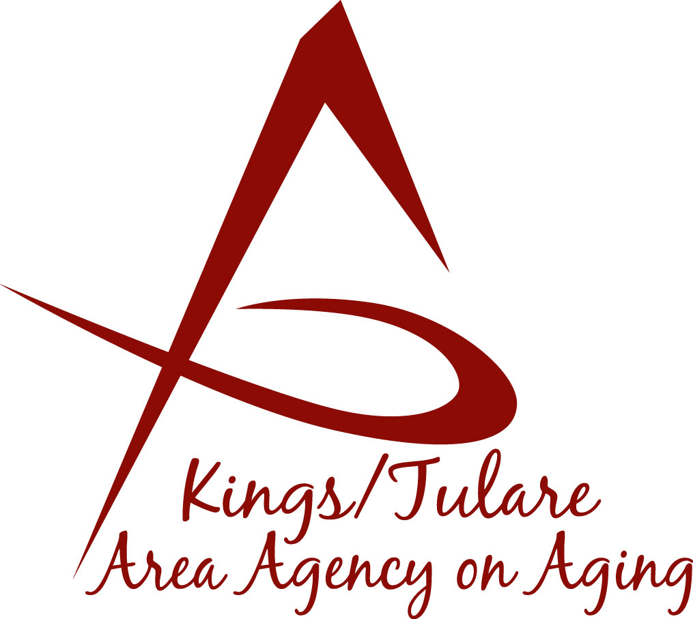**ADVISORY COUNCIL AGENDA**

**Monday, March 17, 2025**

**10:30 a.m.**

**Tulare Co. Connections Bldg.**

3249 W. Noble Avenue

**Visalia, CA 93277**

1. **Call to Order Action**
2. **Introductions of Guests and Council Members Information**

*Welcome to newly appointed members*

1. **Public Comment 3 minutes**

*Any person may directly address the Council at this time on any item on the agenda or any other items of interest to the public that are* *within the subject*

*matter jurisdiction of the K/TAAA.*

1. **Approval of Minutes Action**

*Members present at the previous meeting may comment or correct minutes from the meeting held on January 22, 2024.*

1. **Announcement and Correspondence Information**

**6. Discussion on Meeting Dates and Times Information**

**7. HICAP Presentation** *(Bertha Villalpando, Blanca Alvarez)* **Information**

*Presentation of the Health Insurance Counseling and Advocacy Program.*

**8. Staff Reports Information**

* *Area Plan Survey*

**9. Development of the May 12 2025, Council Agenda Information**

*Discussion of ideas for the May meeting*

**10. Additional Member Comments Information**

**11. Adjourn Action**

*If there is no further business to attend to, members may adjourn the meeting at this time.*

**Notice to the Public**

In compliance with the Americans with Disabilities Act, if you need special assistance to participate in this meeting, please contact Christine Tidwell at (559) 624-8063.

The disclosable public records related to this agenda are available for public inspection at the reception area of the Tulare County Human Services Government Plaza building, 5957 S. Mooney Blvd. Visalia, CA 93277 *For Zoom tele-conference link information call: 559-624-8063.