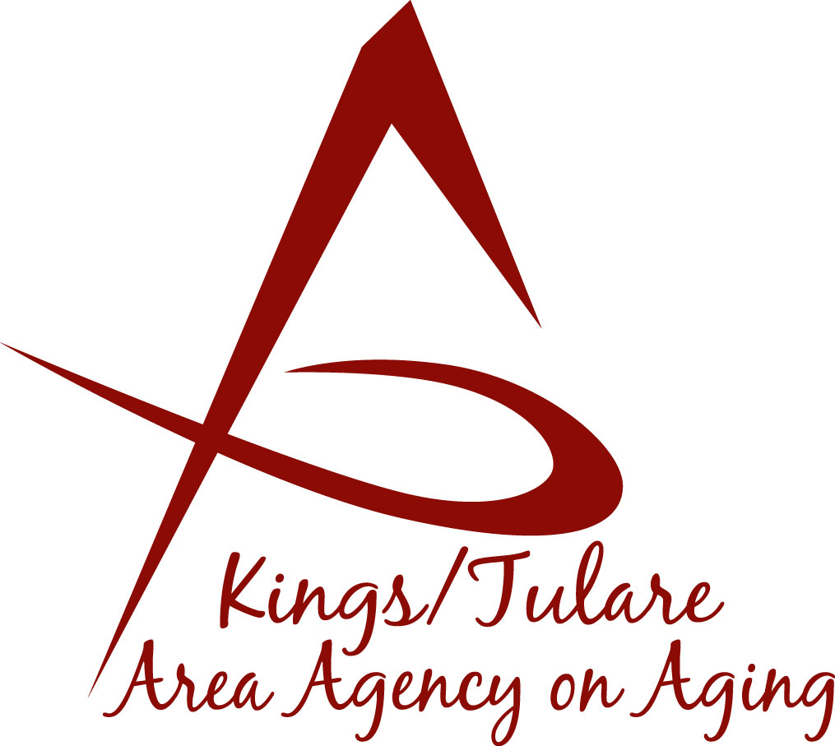**ADVISORY COUNCIL AGENDA**

**Monday, January 13, 2025**

**10:45 a.m.**

**Lindsay Senior Center**

911 N. Parkside Ave.

**Lindsay, CA 93247**

1. **Call to Order Action**
2. **Introductions of Guests and Council Members Information**

*Welcome*

1. **Public Comment 3 minutes**

*Any person may directly address the Council at this time on any item on the agenda or any other items of interest to the public that are* *within the subject*

*matter jurisdiction of the K/TAAA.*

1. **Approval of Minutes Action**

*Members present at the previous meeting may comment or correct minutes from the meeting held on December 17, 2024.*

1. **Announcement and Correspondence Information**
2. **Master Plan on Aging (MPA) Goals** *(Dayna Wild)* **Information**

*For Possible Planning Ideas and Participation by the Advisory Council*

1. **Staff Reports Information**

**10. Development of the March 17, 2025, Council Agenda Information**

*Discussion of ideas for the January meeting - to be held at the Tulare Co. Connections Bldgs., Yosemite Conference Room, 3249 W. Noble, Visalia*

**11. Additional Member Comments Information**

**12. Adjourn Action**

*If there is no further business to attend to, members may adjourn the meeting at this time.*

**Notice to the Public**

In compliance with the Americans with Disabilities Act, if you need special assistance to participate in this meeting, please contact Christine Tidwell at (559) 624-8063.

The disclosable public records related to this agenda are available for public inspection at the reception area of the Tulare County Human Services Government Plaza building, 5957 S. Mooney Blvd. Visalia, CA 93277 *For Zoom tele-conference link information call: 559-624-8063.