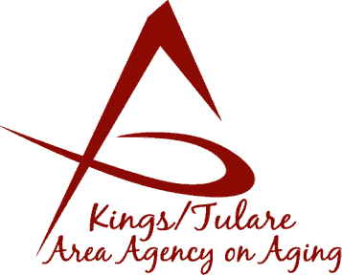
ADVISORY COUNCIL MINUTES

(of) March 20, 2023

MEMBERS PRESENT:
Marlene Chambers
Marianne Osborne
Mary Thomas
Bobbie Wartson, Chair
Betsey Foote

MEMBERS ABSENT:
Sharon Lamagno
Suzann Wray

STAFF PRESENT:
John Mauro, Adult Services, Director
Dayna Wild, K/T AAA Director
Rise VanTichelt, Aging Services Mgr.
Israel Guardado, Administrative Specialist
Aaron Gomes, Administrative Specialist
Bonnie Quiroz, Senior Advocate
Christine Tidwell, Administrative Aide
Rudy Porras, Administrative Aide

GUESTS PRESENT:
Jerel Dutton, CSET
Angel Avita, CSET
Eric Scott, Tulare County Counsel
Jason Kemp Van Ee, Kings County
Ashlee Winslow, City of Tulare Senior Center

- Call to Order – Ms. Bobbie Wartson, Chair, called the meeting to order at 10:45 a.m.

- Introduction of Council Members and Guests – Attendance, as above. (Currently, there are 8 seated members to the Council, 5 making a quorum.)

- Public Comment – Christine Tidwell congratulated Ms. Bobbie Wartson and the KCCOA staff on the complimentary letters that had been sent to the Kings County Board of Supervisors in recognition and appreciation of the services that KCCOA provides. (The letters had been noted and shared at the earlier Governing Board meeting.)

- Approval of Minutes of the January 23, 2023, Meeting – Marlene Chambers motioned for the minutes to be approved, Betsey Foote seconded the motion. The minutes were approved by voice vote.

- Announcements and Correspondence – None.

- Milestone Updates – None.

- Recommendation to Move Applicant’s Name Forward for Appointment – This action was tabled until the May meeting. Mr. Ernest Gibson, a new Council applicant, is being recommended for appointment to the Council. Because Mr. Gibson was not in attendance at the meeting, the Chair held this action item until the May meeting.

- Staff Reports
- Israel Guardado reported that the Public Hearings for the Area Plan have been scheduled and will be held on April 19, 2023, in Kings County at the Hanford Senior Center; and on April 26 at the Cutler Senior Center in Tulare County. He said that participation from Council members is greatly appreciated and always welcome. Both hearings are slated to begin at 10 a.m. He noted that the same information will be given at each hearing.
- Christine Tidwell reminded Council members that the Form 700 (Statement of Economic Interest), is due at this time of year. These forms are housed at the K/T AAA office. Also, it is time for the Ethics Training that comes due every two years. This training is an online course.

- Development of the May 15, Council Agenda – It was noted that the Area Plan, in its finalized stage, should be completed by the May meeting. Additionally, regarding the Requests for Proposal (RFPs), the contracts in connection to the RFPs should be ready to be awarded per the Evaluation Committee’s recommendations. (These are awarded via the Governing Board’s actions).

It was noted that the May meeting will be held at the Corcoran Senior Center.

- Additional Member Comments – None.

- Adjourn –The meeting was adjourned at 11:00 a.m.

